AquaShield: Intelligent Aquaculture Monitoring and Adaptive Protection System Using Machine Learning and IoT
By
1. Md. Shahriar Hossain Srabon ID: 0432310005101056
2. Md. Mahfuz ID: 0432310005101057
3. Hrithik Saha ID: 0432310005101071
Department of Computer Science and Engineering
Faculty of Science and Engineering
A Capstone Project Submitted in partial fulfillment of the requirements for the degree of Bachelor of Science in Computer Science and Engineering
Supervised By
Sultana Rokeya Naher
Associate Professor
Department of Computer Science and Engineering
University of Information Technology and Sciences (UITS)
Baridhara J Block, Dhaka 1212
May, 2026

Declaration
The capstone project work entitled "AquaShield: Intelligent Aquaculture Monitoring and Adaptive Protection System Using Machine Learning and IoT" is a bonafide record of work carried out by Md. Shahriar Hossain Srabon (ID: 0432310005101056), Md. Mahfuz (ID: 0432310005101057), and Hrithik Saha (ID: 0432310005101071) under the supervision of Sultana Rokeya Naher, Associate Professor, Department of Computer Science and Engineering (CSE), University of Information Technology and Sciences (UITS), Dhaka, Bangladesh.
This work, in whole or in part, has not been submitted elsewhere for the award of any degree or diploma.
Candidates:
------------------------------------------------------------------------
- Md. Shahriar Hossain Srabon
Student ID: 0432310005101056
Department of Computer Science and Engineering, UITS
------------------------------------------------------------------------
- Md. Mahfuz
Student ID: 0432310005101057
Department of Computer Science and Engineering, UITS
------------------------------------------------------------------------
- Hrithik Saha
Student ID: 0432310005101071
Department of Computer Science and Engineering, UITS

Approval
This is to certify that the capstone project work submitted by Md. Shahriar Hossain Srabon (ID: 0432310005101056), Md. Mahfuz (ID: 0432310005101057), and Hrithik Saha (ID: 0432310005101071) entitled "AquaShield: Intelligent Aquaculture Monitoring and Adaptive Protection System Using Machine Learning and IoT" has been examined and approved by the Capstone Project Review Committee in partial fulfillment of the requirements for the degree of Bachelor of Science in Computer Science and Engineering (CSE) in the Department of Computer Science and Engineering (CSE), University of Information Technology and Sciences (UITS), Dhaka, Bangladesh in Spring 2026.
CAPSTONE PROJECT REVIEW COMMITTEE
- ................................................................
[Head of Department Name]
Head of the Department
Department of Computer Science and Engineering (CSE)
University of Information Technology and Sciences (UITS)
(Convener)
- ................................................................
Sultana Rokeya Naher
Associate Professor
Department of Computer Science and Engineering (CSE)
University of Information Technology and Sciences (UITS)
(Supervisor)
- ................................................................
[External Examiner Name]
Professor / External Expert
Department of Computer Science and Engineering
University of Information Technology and Sciences (UITS)
(Member)
- ................................................................
[Internal Coordinator Name]
Coordinator, Capstone Project Committee
Department of Computer Science and Engineering (CSE)
University of Information Technology and Sciences (UITS)
(Member Secretary)

Acknowledgement
First of all, we thank Almighty Allah for giving us the patience, health, and ability to complete our capstone engineering project.
We express our sincere gratitude to our supervisor, Sultana Rokeya Naher, Associate Professor, Department of Computer Science and Engineering, University of Information Technology and Sciences (UITS). Her constant advice, regular feedback, and encouragement helped us solve practical hardware problems, design our database, and evaluate our machine learning models correctly.
We also thank the Head of the Department of Computer Science and Engineering and all our teachers and lab staff at UITS for their support and for providing us with the necessary computing and laboratory facilities during our study.
We are thankful to the Bangladesh Water Development Board (BWDB) and Flood Forecasting and Warning Centre (FFWC) for making historical river gauge records available. We also acknowledge Open-Meteo for providing free ERA5 catchment rainfall data.
Finally, we are grateful to our parents and family members for their continuous support and sacrifices throughout our university life. We also thank each other for working together as a team with dedication to build AquaShield.

Justification Report
Below is the Course Outcome to Program Outcome (CO-PO) Mapping, Justification of PO through COs, Complex Engineering Problem (CEP) Justification, and Range of Complex Engineering Activities (CEA) Report for our project titled "AquaShield: Intelligent Aquaculture Monitoring and Adaptive Protection System Using Machine Learning and IoT".

CO-PO Mapping
CO-PO Mapping Matrix for AquaShield
CO No. | Description of CO | KP | CP | CA
CO1 | Apply engineering fundamentals and computing knowledge to identify and translate real-life aquaculture water quality problems and monsoon flood threats into an intelligent IoT and ML solution. | K1, K2, K3, K4 | - | -
CO2 | Identify, formulate, and analyze water quality requirements (pH, TDS, temperature, depth) and flood threshold limits to reach substantiated conclusions using data. | K2, K3, K4 | WP1, WP2, WP3 | -
CO3 | Design and build an integrated system combining an ESP32 sensor node, local relay control logic, cloud data storage, and machine learning prediction models. | K3, K5, K6 | WP1, WP3, WP5 | -
CO4 | Select and apply modern hardware and software tools including ESP32, Arduino C++, Firebase Realtime Database, Python FastAPI, Scikit-learn, and XGBoost. | K3, K5, K6 | WP1, WP3, WP4 | -
CO5 | Function effectively as individual contributors and as a 3-member engineering team with clear task distribution and regular coordination. | - | - | -
CO6 | Demonstrate project management and budgeting skills by keeping the total prototype hardware cost under 7,200 BDT (~\$60) for rural fish farmers. | - | - | -
CO7 | Conduct experimental investigations using laboratory buffer solutions for sensor calibration and 15 years of river data with Leave-One-Year-Out validation. | K6, K8 | WP1, WP2, WP3 | -
CO8 | Assess the real-world impact of the project on rural aquaculture, protecting fish from mortality and saving farmers from severe financial loss. | K8, K7 | WP1, WP3, WP4 | -
CO9 | Evaluate environmental sustainability by minimizing water pumping, preventing chemical over-concentration, and avoiding feed wastage. | K7 | - | -
CO10 | Commit to professional engineering ethics by reporting true empirical results, citing all references properly, and explaining model predictions with SHAP. | K7 | - | -
CO11 | Communicate engineering work clearly through a complete written technical project book and oral defense presentation. | - | - | EA1, EA2, EA3, EA5
CO12 | Recognize the need for lifelong learning by researching future system extensions like on-device TinyML and LoRaWAN wireless networks. | - | - | -

Justification of PO through COs
Justification of PO through COs for AquaShield
CO No. | PO | Justification (with Specific Report References)
CO1 | PO1 | We applied basic electronics, sensor physics (Nernst equation for pH, electrical conductivity for TDS, ultrasonic time-of-flight), and machine learning regression to solve real-world pond water deterioration and river flood overflow in Bangladesh. (Reported in Section 1.2, 3.3, and 3.6).
CO2 | PO2 | We formulated the technical requirements for pond water monitoring and river flood warnings, defining mathematical conversion formulas, 1-hour TDS lag features, and water danger thresholds evaluated using RMSE, MAE, and NSE metrics. (Reported in Section 1.3, 3.6, and 5.3).
CO3 | PO3 | We designed and assembled the complete system: an ESP32 edge node with optocoupler-isolated relays, local autonomous FSM rules for the pumps and the servo feeder, a Firebase Realtime Database cloud layer, and three machine learning models served by a Python FastAPI backend. (Reported in Chapters 3 and 4).
CO4 | PO5 | We selected and used standard modern engineering tools including ESP32 32-bit MCU, PlatformIO/Arduino IDE, Firebase Realtime Database, Python FastAPI, Python Scikit-learn, XGBoost, and SHAP. (Reported in Section 4.2 to 4.6).
CO5 | PO9 | Our 3-member team divided tasks effectively: Srabon handled hardware fabrication and power wiring, Mahfuz integrated the ESP32 with the Firebase Realtime Database and built the web dashboard, and Hrithik developed the Python FastAPI backend and the ML flood forecasting and anomaly detection models. (Reported in Section 4.1).
CO6 | PO11 | We managed component procurement and prepared a detailed Bill of Materials totaling 6,570 BDT (\$55.15 USD), proving our system is affordable for marginal fish farmers in Bangladesh. (Reported in Section 3.3, Table 3.1).
CO7 | PO4 | We conducted practical investigations: we calibrated the pH sensor with vinegar (pH 2.4) and baking soda (pH 8.3) reference solutions, evaluated sensor accuracy against standard buffer solutions, and validated our river flood model on 15 years (2008--2022) of BWDB records using Leave-One-Year-Out (LOYO) cross-validation to prevent data leakage. (Reported in Section 3.3, 3.7, 5.2, and 5.3).
CO8 | PO6 | We evaluated the socioeconomic impact on rural communities: preventing fish kills protects farmer income, safeguards food security, and avoids financial devastation during monsoon river overflows. (Reported in Section 1.1, 2.2, and 6.1).
CO9 | PO7 | We designed closed-loop control rules that save water by pumping only when necessary, prevent pond pollution from excess feed, and use energy-efficient 12V DC power components. (Reported in Section 3.4 and 4.2).
CO10 | PO8 | We maintained academic honesty by using real observed datasets, reporting actual prediction errors without bias, explaining tree predictions via SHAP, and properly citing all literature. (Reported in Section 5.4, 5.7, and References).
CO11 | PO10 | We wrote this complete, well-documented technical capstone report adhering to UITS and IEEE standards, created 13 figures (Figure 3.1 to Figure 5.11) and 15 numbered tables, and prepared slides for our oral defense. (Reported throughout the entire book and the report).
CO12 | PO12 | We recognized that technology continues to evolve, so we studied and documented future upgrade paths including running TinyML directly on the ESP32 and adding LoRaWAN mesh networking. (Reported in Section 6.2).

Complex Engineering Problem (CEP) Justification
Complex Engineering Problem (CEP) Justification Matrix
Attribute Category | Attribute Name & ID | BAETE Criteria [24] & Project Justification (with Report References)
1. Mandatory Attribute | Depth of Knowledge (P1) | Solving this problem required knowledge from multiple engineering fields (K4): embedded systems (ADC oversampling, voltage-divider interfacing, 3.3V analog sensor design), cloud data handling (Firebase Realtime Database, Python FastAPI REST services), time-series machine learning, and Explainable AI (SHAP). We studied research literature (K8) to handle time-series data leakage and peak extrapolation. (Reported in Section 2.4, 2.5, 3.6, 5.3).
2. Supporting Attribute | Range of Conflicting Requirements (P2) | We balanced conflicting constraints: low hardware cost (<\$60) vs. good sensor accuracy; real-time cloud updates vs. frequent rural internet dropouts; and long flood forecast horizons (+14 days) vs. growing prediction error. (Reported in Section 1.2, 3.4, 5.6).
3. Supporting Attribute | Depth of Analysis Required (P3) | Standard random train-test splitting fails on river data because it leaks future temporal information. We designed a Leave-One-Year-Out cross-validation scheme and analyzed stratified water-level errors across 5,479 days to prove why linear models beat tree models during extreme flood crests. (Reported in Section 3.7, 5.3, 5.7).
4. Supporting Attribute | Familiarity of Issues (P4) | Real aquaculture ponds do not have labeled 'good water' vs. 'bad water' datasets. We handled this unfamiliar unsupervised scenario by combining sensor rate-of-change deltas with Isolation Forest, successfully isolating dangerous multivariate conditions like high pH + high temperature. (Reported in Section 2.2, 3.6, 5.5).
5. Supporting Attribute | Interdependence (P7) | The parts of our system depend heavily on each other: hardware ADC calibration directly determines data accuracy; clean cloud data feeds the ML models; and ML flood early warnings give farmers lead time to raise perimeter netting. (Reported in Section 3.2, 4.7, 5.6).

Range of Complex Engineering Activities (CEA) Justification
Range of Complex Engineering Activities (CEA) Justification Matrix
Activity ID | Activity Title | Engineering Activity Justification (with Report References)
A1 | Range of Resources | We utilized diverse hardware components (ESP32, pH-4502C, TDS probe, NTC thermistor, HC-SR04, optocoupled relays, buck converter), software stacks (Firebase Realtime Database, Python FastAPI, vanilla HTML/CSS/JavaScript), and 15 years of BWDB hydrological records and ERA5 rainfall data. (Reported in Chapter 3 and Chapter 4).
A3 | Innovation | We combined macro-scale river flood forecasting (giving 3 to 7 days warning to protect pond dikes) with micro-scale pond water automation and unsupervised anomaly detection, adding SHAP explainability so farmers can understand the alerts. (Reported in Section 3.2, 3.6, 5.4).
A4 | Consequences for Society & Environment | Our project directly helps fish farmers in flood-prone districts of Bangladesh avoid financial bankruptcy, protects national food supply, reduces clean water wastage, and avoids toxic chemical spikes. (Reported in Section 1.1, 2.2, 6.1).

Mapping to PO10 (Communication)
- Written Technical Documents: Prepared the technical capstone report in accordance with the UITS format [25] and IEEE citation conventions.
- Oral Presentations: Prepared formal multimedia presentation slides for the Capstone Review Committee defense.
- Visual Representation: Presented technical figures, including the system architecture schematic (Figure 3.1), the LOYO validation workflow (Figure 3.2), flood-season hydrographs (Figure 5.3), the SHAP summary plot (Figure 5.8), and the anomaly detection scatter plot (Figure 5.9), together with tables summarizing hardware, control rules, and experimental results.

Abstract
Fish farming is an important part of Bangladesh's economy, contributing more than 3.5% of national GDP and supplying approximately 60% of animal protein. However, fish farmers face risks from unmonitored pond water deterioration and seasonal monsoon flooding. This capstone project presents AquaShield, a low-cost IoT-based aquaculture monitoring and decision-support system that combines local automation, cloud telemetry, and three machine learning models.
The physical edge node uses an ESP32 microcontroller with pH, Total Dissolved Solids (TDS), temperature, and ultrasonic water-level sensors. A finite-state machine (FSM) operates the drain pump, refill pump, and servo-based feeder at 30-second intervals, while local safety rules continue during network interruptions. Telemetry is stored in Firebase Realtime Database, and the machine learning models are served through a Python FastAPI backend.
The machine learning subsystem includes (1) river water-level forecasting at Bahadurabad on the Jamuna River using 15 years (2008--2022) of BWDB data and ERA5 rainfall, evaluated over 1--14 day horizons using Leave-One-Year-Out (LOYO) validation, with +1, +3, +7, and +14 day checkpoints reported in detail; (2) 60-minute-ahead pond TDS forecasting using rolling statistics and comparative regression models with SHAP interpretation; and (3) unsupervised multivariate anomaly detection using Isolation Forest and sensor rate-of-change features. On the unseen 2020--2022 holdout period at the +3-day horizon, Linear Regression achieved an NSE of 0.9851 and RMSE of 0.3082 m. For TDS forecasting, Linear Regression was the strongest learned model (MAE 7.05 ppm, R² 0.888), although the persistence baseline performed better overall. The prototype hardware cost was 6,570 BDT, below the 7,200 BDT target. Overall, the project demonstrates the feasibility of integrating low-cost sensing, local automation, cloud telemetry, and machine learning for aquaculture decision support in Bangladesh.
Keywords: Internet of Things (IoT), Water Quality Monitoring, River Flood Early Warning, Machine Learning, Explainable AI (SHAP).

Preface
This Bachelor of Science (B.Sc.) capstone project report describes the engineering design, embedded hardware prototyping, cloud software development, and machine learning experiments conducted in the Department of Computer Science and Engineering (CSE), Faculty of Science and Engineering, at the University of Information Technology and Sciences (UITS), Dhaka, Bangladesh.
The project is structured into six chapters, summarized below:
Chapter 1 (Introduction): Introduces aquaculture in Bangladesh, explains the problems of silent water quality deterioration and monsoon river flooding (motivation), defines the aims and technical objectives of AquaShield, outlines the project challenges and scope, and lists the main contributions.
Chapter 2 (Background Studies): Explains key pond water quality parameters (pH, TDS, temperature, ammonia), reviews monsoon flood patterns in the Jamuna basin, surveys existing IoT aquaculture systems, reviews machine learning in hydrology, and summarizes technical gaps.
Chapter 3 (Methodology): Presents the overall 5-tier architecture, hardware sensor equations and the 3.3V pH sensor design, edge FSM actuation rules, offline fail-safe logic, Firebase cloud telemetry and the FastAPI backend, the methodology of the three ML models, and validation protocols.
Chapter 4 (Implementation): Details the physical hardware build, power supply design, ESP32 C++ firmware with ADC oversampling, Firebase Realtime Database and Python FastAPI cloud services, Python ML pipelines, the web dashboard, and web dashboard alert banners.
Chapter 5 (Result Analysis and Comparison): Presents laboratory sensor calibration results, Model 1 river flood forecasting performance across 1 to 14 days with peak extrapolation analysis and the dashboard safety buffer, Model 2 TDS forecasts with SHAP plots, Model 3 multivariate anomaly isolation, system latency benchmarks, and technical findings relevant to system evaluation.
Chapter 6 (Conclusion & Future Work): Summarizes the project conclusion and limitations, and outlines future improvements such as TinyML and LoRaWAN long-range networking.
Appendices & References: Appendix A provides complete pinout connections and REST API routes. References lists 25 formal IEEE citations, followed by the institutional Plagiarism Report placeholder.

Table of Contents
Declaration 2
Approval 2
Acknowledgement 4
Justification Report 4
CO-PO Mapping 5
Justification of PO through COs 6
Complex Engineering Problem (CEP) Justification 8
Range of Complex Engineering Activities (CEA) Justification 9
Mapping to PO10 (Communication) 10
Abstract 10
Preface 11
List of Figures 14
List of Tables 15
Abbreviations and Symbols 15
Chapter 1: Introduction 18
1.1 Introduction 18
1.2 Problem Statement 18
1.3 Motivation 18
1.4 Aims and Objectives 19
1.5 Challenges and Scope 20
1.6 Contribution 20
1.7 Conclusion 21
Chapter 2: Background Studies 22
2.1 Introduction 22
2.2 Aquaculture Challenges and Water Quality Dynamics in Bangladesh 22
2.3 Monsoon Flooding Risks and Early Warning Needs 23
2.4 Review of Existing IoT Aquaculture Monitoring Systems 23
2.5 Machine Learning in Hydrological Forecasting & Water Quality Prediction 23
2.6 Comparative Analysis of Related Works and Research Gap 24
2.7 Conclusion 24
Chapter 3: Methodology 25
3.1 Introduction 25
3.2 Overall System Architecture and Telemetry Pipeline 25
3.3 Hardware Design and Edge Sensing Layer 26
3.4 Local Edge Control Logic, Fail-Safe Automation, and Actuator Drivers 28
3.5 Cloud Telemetry, REST API, and Database Schema 29
3.6 Machine Learning Subsystem Methodology 29
3.7 Model Validation Protocols (LOYO CV and Chronological Splitting) 29
3.8 Conclusion 30
Chapter 4: Implementation 31
4.1 Introduction 31
4.2 Hardware Fabrication, Circuit Wiring, and Power Supply Setup 31
4.3 ESP32 Firmware Development & Local Sensing Pipeline 32
4.4 Backend & Database Service Implementation 32
4.5 Machine Learning Subsystem Implementation & Deployment Pipeline 32
4.6 Web Dashboard & Sensor Calibration Interface Development 32
4.7 Automated Alerting Subsystem & Web Dashboard Alert Banners 33
4.8 Conclusion 33
Chapter 5: Result Analysis and Comparison 34
5.1 Introduction 34
5.2 IoT Hardware Performance and Sensor Calibration Results 34
5.3 Model 1 (River Flood Forecast) Experimental Evaluation 34
5.4 Model 2 (Pond TDS Forecast) Results and SHAP Explainability 40
5.5 Model 3 (Pond Anomaly Detection) Evaluation and Diagnostic Analysis 44
5.6 Real-Time Actuation and Inference Latency 46
5.7 Comprehensive Discussion & Technical Defense Insights 46
5.8 Conclusion 46
Chapter 6: Conclusion and Future Work 46
6.1 Conclusion 46
6.2 Future Work 46
Appendix A: Hardware Pin Mappings and REST API Endpoints 47
A.1 Complete Hardware Pinout Specifications 48
A.2 AquaShield REST API Endpoints Specification 49
References 50
Plagiarism Report 52

List of Figures
Figure 3.1: High-level 5-tier cyber-physical architecture and catchment integration schematic of AquaShield 25
Figure 3.2: Leave-One-Year-Out (LOYO) cross-validation and strict holdout evaluation protocol 30
Figure 5.1: Correlation and physical lag dynamics between catchment rainfall and Bahadurabad river water level 35
Figure 5.2: Model Root Mean Squared Error (RMSE) vs. forecast lead time (1 to 14 days) across all evaluated algorithms 36
Figure 5.3: Flood season hydrographs: observed vs. predicted water levels during major historical monsoon flood years 37
Figure 5.4: Model 1 feature importance distribution shifting from autoregressive water-level lags to upstream rainfall sums 39
Figure 5.5: Final holdout model performance on unseen 2020--2022 monsoon seasons (+3 days lead horizon) 40
Figure 5.6: Model 2 performance comparison bar chart across MAE, RMSE, and R² metrics 41
Figure 5.7: Model 2 actual vs. predicted TDS time series over the held-out test dataset 42
Figure 5.8: SHAP feature importance summary plot explaining Model 2 TDS forecasts 43
Figure 5.9: Model 3 bivariate scatter plot (pH vs. TDS) highlighting detected multivariate anomalies 44
Figure 5.10: Model 3 anomaly detection timeline traced along continuous TDS sensor readings 45
Figure 5.11: Isolation Forest anomaly score distribution and 5% contamination decision threshold 45

List of Tables
Table 2.1: Water Quality Thresholds and Biological Tolerance for Major Farmed Fish Species 22
Table 2.2: Comparative Feature Matrix of Existing Aquaculture Systems vs. AquaShield 24
Table 3.1: Hardware Bill of Materials (BOM) and Cost Breakdown 26
Table 3.2: Summary of Primary Hardware Pin Assignments on ESP32 27
Table 3.3: Summary of Edge Finite State Machine (FSM) Actuation Rules 28
Table 5.1: Sensor Calibration and Precision Evaluation Across Reference Measurements 34
Table 5.2: Bahadurabad Station Hydrological Dataset Summary (2008--2022) 34
Table 5.3: Hyperparameter Search Grids and Selected Optimal Values for Model 1 35
Table 5.4: Comprehensive LOYO Cross-Validation Performance Metrics (+1 Day Horizon) 36
Table 5.5: Extreme Flood Season and Peak Error Evaluation Metrics 38
Table 5.6: Final Holdout Evaluation Results on Unseen 2020--2022 Monsoon Seasons (+3 Days) 39
Table 5.7: Model 2 Pond TDS Forecasting Performance Comparison (+60 Mins Horizon) 40
Table 5.8: End-to-End Latency Benchmark Results 46
Table A.1: Complete Hardware Pinout and Bus Interfacing Specifications 48
Table A.2: AquaShield REST API Endpoints Specification (Python FastAPI ML Backend) 49

Abbreviations and Symbols
Acronym / Symbol | Full Meaning / Definition
ADC | Analog-to-Digital Converter
AI | Artificial Intelligence
API | Application Programming Interface
BAETE | Board of Accreditation for Engineering and Technical Education
BLE | Bluetooth Low Energy
BOM | Bill of Materials
BWDB | Bangladesh Water Development Board
CA | Complex Activities
CEA | Complex Engineering Activities
CEP | Complex Engineering Problem
CO | Course Outcome
CP | Complex Problem
CSE | Computer Science and Engineering
CSS | Cascading Style Sheets
CV | Cross-Validation
DC | Direct Current
DO | Dissolved Oxygen
ERA5 | ECMWF Reanalysis v5 Global Climate Dataset
ESP32 | Espressif Systems 32-bit Wi-Fi/BLE Microcontroller
FAR | False Alarm Rate
FFWC | Flood Forecasting and Warning Centre (Bangladesh)
FSM | Finite State Machine
GPIO | General Purpose Input/Output
HTML | HyperText Markup Language
HTTP | Hypertext Transfer Protocol
IDE | Integrated Development Environment
IEEE | Institute of Electrical and Electronics Engineers
IoT | Internet of Things
KP | Knowledge Profile
LOYO | Leave-One-Year-Out Cross-Validation
LSTM | Long Short-Term Memory Neural Network
MAE | Mean Absolute Error
MCU | Microcontroller Unit
ML | Machine Learning
NSE | Nash-Sutcliffe Efficiency
NTC | Negative Temperature Coefficient
NVS | Non-Volatile Storage
pH | Potential of Hydrogen (Acidity/Basicity Measure)
PO | Program Outcome
POD | Probability of Detection (Hit Rate)
PWM | Pulse Width Modulation
REST | Representational State Transfer
RHWL | Recorded Highest Water Level
RMSE | Root Mean Squared Error
R² | Coefficient of Determination
SDK | Software Development Kit
SHAP | SHapley Additive exPlanations
SPIFFS | Serial Peripheral Interface Flash File System
SVR | Support Vector Regressor
TDS | Total Dissolved Solids (measured in ppm)
UITS | University of Information Technology and Sciences
Wi-Fi | Wireless Fidelity (IEEE 802.11 b/g/n)
WP | Workplace / Complex Problem Profile Attribute
XGBoost | Extreme Gradient Boosting

Chapter 1: Introduction

1.1 Introduction
In Bangladesh, fish farming is one of the most vital agricultural sectors. It contributes more than 3.5% to the national Gross Domestic Product (GDP) and provides roughly 60% of the animal protein consumed across the country [1], [2]. Over 18 million people depend on fisheries and aquaculture for their daily livelihood. Over the last two decades, fish farming has shifted from traditional low-density ponds to high-density commercial aquaculture. Species like Rohu (Labeo rohita), Catla (Gibelion catla), Pangas (Pangasius hypophthalmus), and Tilapia (Oreochromis niloticus) are widely farmed in key aquaculture districts such as Mymensingh, Bogura, and Jamalpur.
While high-density stocking increases fish production, it also creates serious environmental risks in the pond. Fish waste and uneaten feed accumulate quickly on the pond bed. When water temperature rises or pH levels shift, harmless ammonium ions turn into more toxic unionized ammonia (NH3), which can cause severe fish mortality. At the same time, because Bangladesh is a low-lying river delta, fish farms in river basins face recurring monsoon floods. Flash floods from the Jamuna River often overtop pond dikes, allowing mature fish to escape into open floodwaters and wiping out a farmer's investment in a single day [4]. To solve both of these problems, the project team designed AquaShield---an integrated IoT and Machine Learning decision-support and automation system built specifically for fish farmers in Bangladesh.

1.2 Problem Statement
Small- and medium-scale fish farmers in Bangladesh face four major operational challenges. (1) Continuous real-time water quality monitoring is limited, although parameters such as pH, TDS, and temperature can change throughout the day. (2) Automated protective actions are generally unavailable, requiring farmers to respond manually when abnormal conditions occur. (3) Limited historical sensor data restricts evidence-based decision-making and may contribute to practices such as excessive feeding and associated increases in TDS. (4) Monsoon river flooding can cause sudden water-level increases and pond inundation, while farmers may not receive localized advance warnings needed to protect fish stocks.

1.3 Motivation
The motivation for AquaShield is driven by the need to connect continuous pond monitoring with timely protective action and flood preparedness in a low-cost system suitable for Bangladeshi aquaculture. Water-quality parameters can change between manual inspections, while monsoon flooding can develop faster than farmers can respond using observation alone.
AquaShield therefore combines an ESP32-based sensing and control node with cloud telemetry, a live dashboard, and machine learning components. The edge controller can continue local safety rules during network interruptions, while the predictive models provide additional information for river-flood risk, short-horizon TDS behavior, and unusual multivariate water conditions.
The project also targets practical affordability. The hardware design was developed around a target cost below 7,200 BDT (approximately 60 USD), while the prototype integrates monitoring, pump control, feeding, alerting, and predictive analysis in one system rather than treating these functions as separate tools.

1.4 Aims and Objectives
The main aim of this project is to develop and evaluate AquaShield as an affordable cyber-physical aquaculture management and flood-warning system. The specific objectives are to:
- Develop a multi-sensor IoT node using an ESP32 microcontroller with pH, TDS, NTC thermistor temperature, and HC-SR04 ultrasonic water-level sensors, with measurements acquired at 30-second intervals.
- Develop local finite-state-machine (FSM) control logic on the ESP32 for the drain pump, refill pump, and servo-based feeder, with local safety operation maintained during network disconnection; flash-based telemetry buffering is identified as a future enhancement.
- Implement a cloud telemetry and dashboard pipeline using the Firebase Realtime Database, a Python FastAPI service for machine learning inference, and web-based alert banners.
- Develop and evaluate a river flood forecasting model using 15 years (2008--2022) of BWDB water-level records and ERA5 rainfall data for the Bahadurabad station on the Jamuna River, with forecast horizons from 1 to 14 days and Leave-One-Year-Out validation.
- Develop and evaluate a 60-minute-ahead pond TDS forecasting model using rolling statistics, comparing linear and tree-based models and applying SHAP for model interpretation.
- Develop an unsupervised pond water-quality anomaly detection model using Isolation Forest and sensor rate-of-change features to identify unusual multivariate conditions without requiring labeled failure data.
- Develop an interactive web dashboard and calibration interface providing live sensor readings, a Pond Health Index (0--100), historical trends, manual pump controls, and a two-point pH calibration workflow.

1.5 Challenges and Scope
Project Scope and Limitations. The prototype comprises the physical sensor circuit, ESP32 firmware, Firebase Realtime Database, Python FastAPI machine learning service, live web dashboard with alert banners, and three machine learning models. Model 1 is calibrated for the Bahadurabad transit station on the Jamuna River, while Models 2 and 3 use pond IoT sensor telemetry. The prototype uses 2.4 GHz Wi-Fi for telemetry; remote rural ponds without Wi-Fi would require a GSM-based communication module. The pH probe requires manual cleaning every 2 to 4 weeks to remove biofilm. AquaShield is an environmental monitoring and decision-support system and does not directly diagnose fish diseases.
Hardware Challenges. The main hardware challenges encountered during development were protecting the ESP32 ADC inputs from the 5 V output of the pH sensor module and preventing voltage drops caused by pump activation from resetting the ESP32. The corresponding design measures are described in Sections 3.3 and 4.2.

1.6 Contribution
- Affordable Edge Node: Built a low-cost (<\$60) multi-sensor edge node with optical relay isolation and ADC noise filtering.
- Offline Edge Fail-Safe: Programmed local FSM rules ensuring continuous pump control during internet outages.
- Dual-Horizon Protection: Integrated river flood forecasting with pond-level automation, with forecasts evaluated from 1 to 14 days ahead and a practical advance-warning focus of 3 to 7 days.
- Leakage-Aware Flood Validation: Evaluated the flood-forecasting models using LOYO cross-validation and analyzed their peak-extrapolation performance.
- Unsupervised Anomaly Detection: Applied Isolation Forest to identify multi-parameter abnormal conditions without requiring labeled failure datasets.
Organization of the Report. This report is organized into six chapters. Chapter 1 introduces the project background, problem statement, motivation, objectives, scope, and contributions. Chapter 2 reviews relevant aquaculture water-quality concepts, flood hazards, existing IoT systems, machine learning approaches, and the identified research gap. Chapter 3 presents the system architecture, hardware design, control logic, cloud pipeline, machine learning methodology, and validation protocols. Chapter 4 describes the implementation of the hardware, firmware, cloud services, machine learning pipelines, dashboard, and alerting subsystem. Chapter 5 presents the experimental results and comparative analysis. Chapter 6 summarizes the findings, limitations, and future work.
This chapter established the importance of fish farming in Bangladesh, identified the principal water-quality and flood-related problems addressed by AquaShield, and defined the project objectives and contributions. Chapter 2 reviews the relevant background and related work.

1.7 Conclusion
This chapter introduced the aquaculture context, identified the principal water-quality and flood-related challenges, defined the motivation and objectives of AquaShield, and summarized its scope and contributions. The next chapter reviews the relevant background studies and related work.

Chapter 2: Background Studies

2.1 Introduction
To build an effective pond monitoring and flood warning system, it is important to understand the biological water limits for fish, the patterns of monsoon river flooding in Bangladesh, and what existing IoT and machine learning research has accomplished. This chapter reviews these areas and highlights the technical gaps the project addresses.

2.2 Aquaculture Challenges and Water Quality Dynamics in Bangladesh
Fish are cold-blooded animals, meaning their health, growth, and survival depend directly on water temperature and chemical parameters. Four main water parameters must be kept within safe boundaries [5], [6]:
pH (Potential of Hydrogen). Safe range is 6.5 to 8.5. Low pH (<6.0) causes gill irritation and body slime. High pH (>8.8) causes gill damage and turns harmless ammonium into more toxic unionized ammonia (NH3).
Total Dissolved Solids (TDS). Safe range is 150 to 450 ppm. High TDS (>600 ppm) indicates excess unconsumed feed, organic waste, or fertilizer runoff, causing osmotic stress and clogging gills.
Water Temperature. Optimal range is 25.0°C to 30.0°C. Water holds less dissolved oxygen when it gets hot (>32°C), while fish consume more oxygen due to higher metabolism. High heat also multiplies ammonia toxicity.
Pond Water Level. The nominal target depth is 80 to 150 cm. The prototype drain rule is intentionally configured as a conservative demonstration trigger at 85 cm, with pump shut-off below 75 cm. Because this trigger lies within the nominal operating range, the threshold should be recalibrated to the actual pond geometry and freeboard before field deployment.
Table 2.1: Water Quality Thresholds and Biological Tolerance for Major Farmed Fish Species
Parameter | Optimal Range | Stress Threshold (Warning) | Lethal Limit (Critical) | Impact on Fish Health
pH | 6.5 -- 8.5 | < 6.2 or > 8.8 | < 5.0 or > 9.5 | Gill burns, respiratory failure, ammonia toxicity spike
TDS (ppm) | 150 -- 450 | 450 -- 600 | > 800 | Osmotic stress, gill clogging, excessive organic waste
Temperature (°C) | 25.0 -- 30.0 | 30.0 -- 33.0 or < 20.0 | > 35.0 or < 15.0 | Low oxygen, metabolic collapse, stopped feeding
Water Level (cm) | 80 -- 150 | < 60 (Low) / > 160 (High) | < 40 (Dry) / > 180 (Overflow) | Fast temperature changes, dike overtopping, fish escape

2.3 Monsoon Flooding Risks and Early Warning Needs
Over 92% of the catchment area of Bangladesh's rivers lies outside the country. During the monsoon (June to October), heavy rainfall in the Himalayas and Meghalaya hills discharges down into the Brahmaputra-Jamuna river system. At the Bahadurabad transit gauge in Jamalpur, water levels frequently cross the official 19.05m Danger Level. In major flood years like 2017, 2019, and 2020, water levels passed 20.50m. In 2020 alone, over 40,000 hectares of commercial fish ponds were submerged, causing financial losses of over 500 crore BDT (\$45M USD) [3]. National agency bulletins give macro basin forecasts, but fish farmers need a 3 to 7-day advance warning for their local river station so they have enough time to set up high nylon nets around their pond dikes or harvest mature fish early.

2.4 Review of Existing IoT Aquaculture Monitoring Systems
Early IoT systems used simple Arduino boards with ZigBee or Bluetooth, but their range was too short and they did not control any pumps. Later systems used ESP8266 or ESP32 boards streaming to platforms like ThingSpeak or Blynk. However, these systems rely completely on continuous internet: if Wi-Fi drops, all monitoring and automatic pump actions stop. Commercial industrial PLC systems cost thousands of dollars (\$2,000--\$10,000) and are completely out of reach for small fish farmers in Bangladesh.

2.5 Machine Learning in Hydrological Forecasting & Water Quality Prediction
In hydrology, data-driven machine learning models (Ridge [17], SVR, Random Forest [16], XGBoost [15]) offer a practical alternative to complex physics simulations. However, many published studies make a major mistake: they use standard random K-Fold cross-validation on time-series data. Shuffling data points leaks future days into the training set, giving falsely high accuracy scores. In addition, decision tree ensembles (Random Forest and XGBoost) cannot predict values higher than the maximum number in their training data, meaning they underestimate unprecedented flood peaks. In pond water monitoring, supervised ML models fail because farmers do not have labeled 'bad water' datasets. An unsupervised model like Isolation Forest [13] is needed to detect unusual multi-sensor combinations without needing manual labels.

2.6 Comparative Analysis of Related Works and Research Gap
Table 2.2 compares AquaShield with eight previous systems from recent research and industry:
Table 2.2: Comparative Feature Matrix of Existing Aquaculture Systems vs. AquaShield
System / Research Study | Microcontroller | Key Sensors | Local Auto Actuation | Offline Fail-Safe | River Flood Forecast | Pond ML & Anomaly Detection | Cost (USD)
Saha et al. (2018) [7] | Arduino Uno | pH, Temp, DO | No (Alerts Only) | No | No | No | \$120
Raju et al. (2020) [8] | Raspberry Pi | pH, Temp, Level | Yes (Pumps) | Partial | No | No | \$180
Hasan et al. (2021) [9] | ESP8266 | pH, TDS, Temp | No | No | No | Basic Thresholds | \$75
Islam et al. (2022) [10] | ESP32 | pH, Temp, Turbidity | Yes (Aerator) | No | No | Simple Linear Reg | \$95
Chen et al. (2023) [11] | Industrial PLC | Optical DO, pH, ORP | Yes (Multi-Relay) | Yes | No | LSTM DO Forecast | \$1,500+
Ahmed et al. (2024) [12] | ESP32 | pH, TDS, Level | Yes (Drain/Refill) | No | No | No | \$85
Commercial AquaMaster | Proprietary | Full Water Suite | Full PLC Control | Yes | No | Proprietary Rules | \$3,500+
AquaShield (Our Work) | ESP32 (Dual Core) | pH, TDS, Temp, Ultrasonic | Yes (Drain, Refill, Feeder) | Yes (Full Edge FSM) | Yes (BWDB LOYO CV +1 to +14d) | Yes (Model 2 TDS + Model 3 IsoForest) | < \$60
Research Gaps Identified. The reviewed studies indicate four principal gaps: (1) limited integration between river-scale flood forecasting and pond-level automated protection; (2) dependence on network connectivity for some automated monitoring and control functions; (3) inadequate temporal validation strategies for flood forecasting that can introduce look-ahead leakage; and (4) limited availability of labeled datasets for pond water-quality anomaly detection. AquaShield addresses these gaps through integrated river and pond monitoring, local edge control, Leave-One-Year-Out validation, and unsupervised anomaly detection.

2.7 Conclusion
This chapter reviewed fish water-quality requirements, monsoon flood patterns, existing aquaculture IoT platforms, and relevant machine learning approaches. The identified research gaps provide the basis for the methodology presented in Chapter 3.

Chapter 3: Methodology

3.1 Introduction
This chapter describes the design of AquaShield, including the five-tier architecture, sensor models and equations, edge control rules, cloud data pipeline, mathematical formulations for the three machine learning models, and validation methods.

3.2 Overall System Architecture and Telemetry Pipeline
AquaShield is organized into five connected tiers: (1) Physical Sensors and Actuators at the pond; (2) Edge Computing on the ESP32 for local control; (3) Cloud Telemetry using the Firebase Realtime Database; (4) Machine Learning Analytics through the three prediction and anomaly-detection models served by the FastAPI backend; and (5) User Interface and Alerts through the web dashboard.

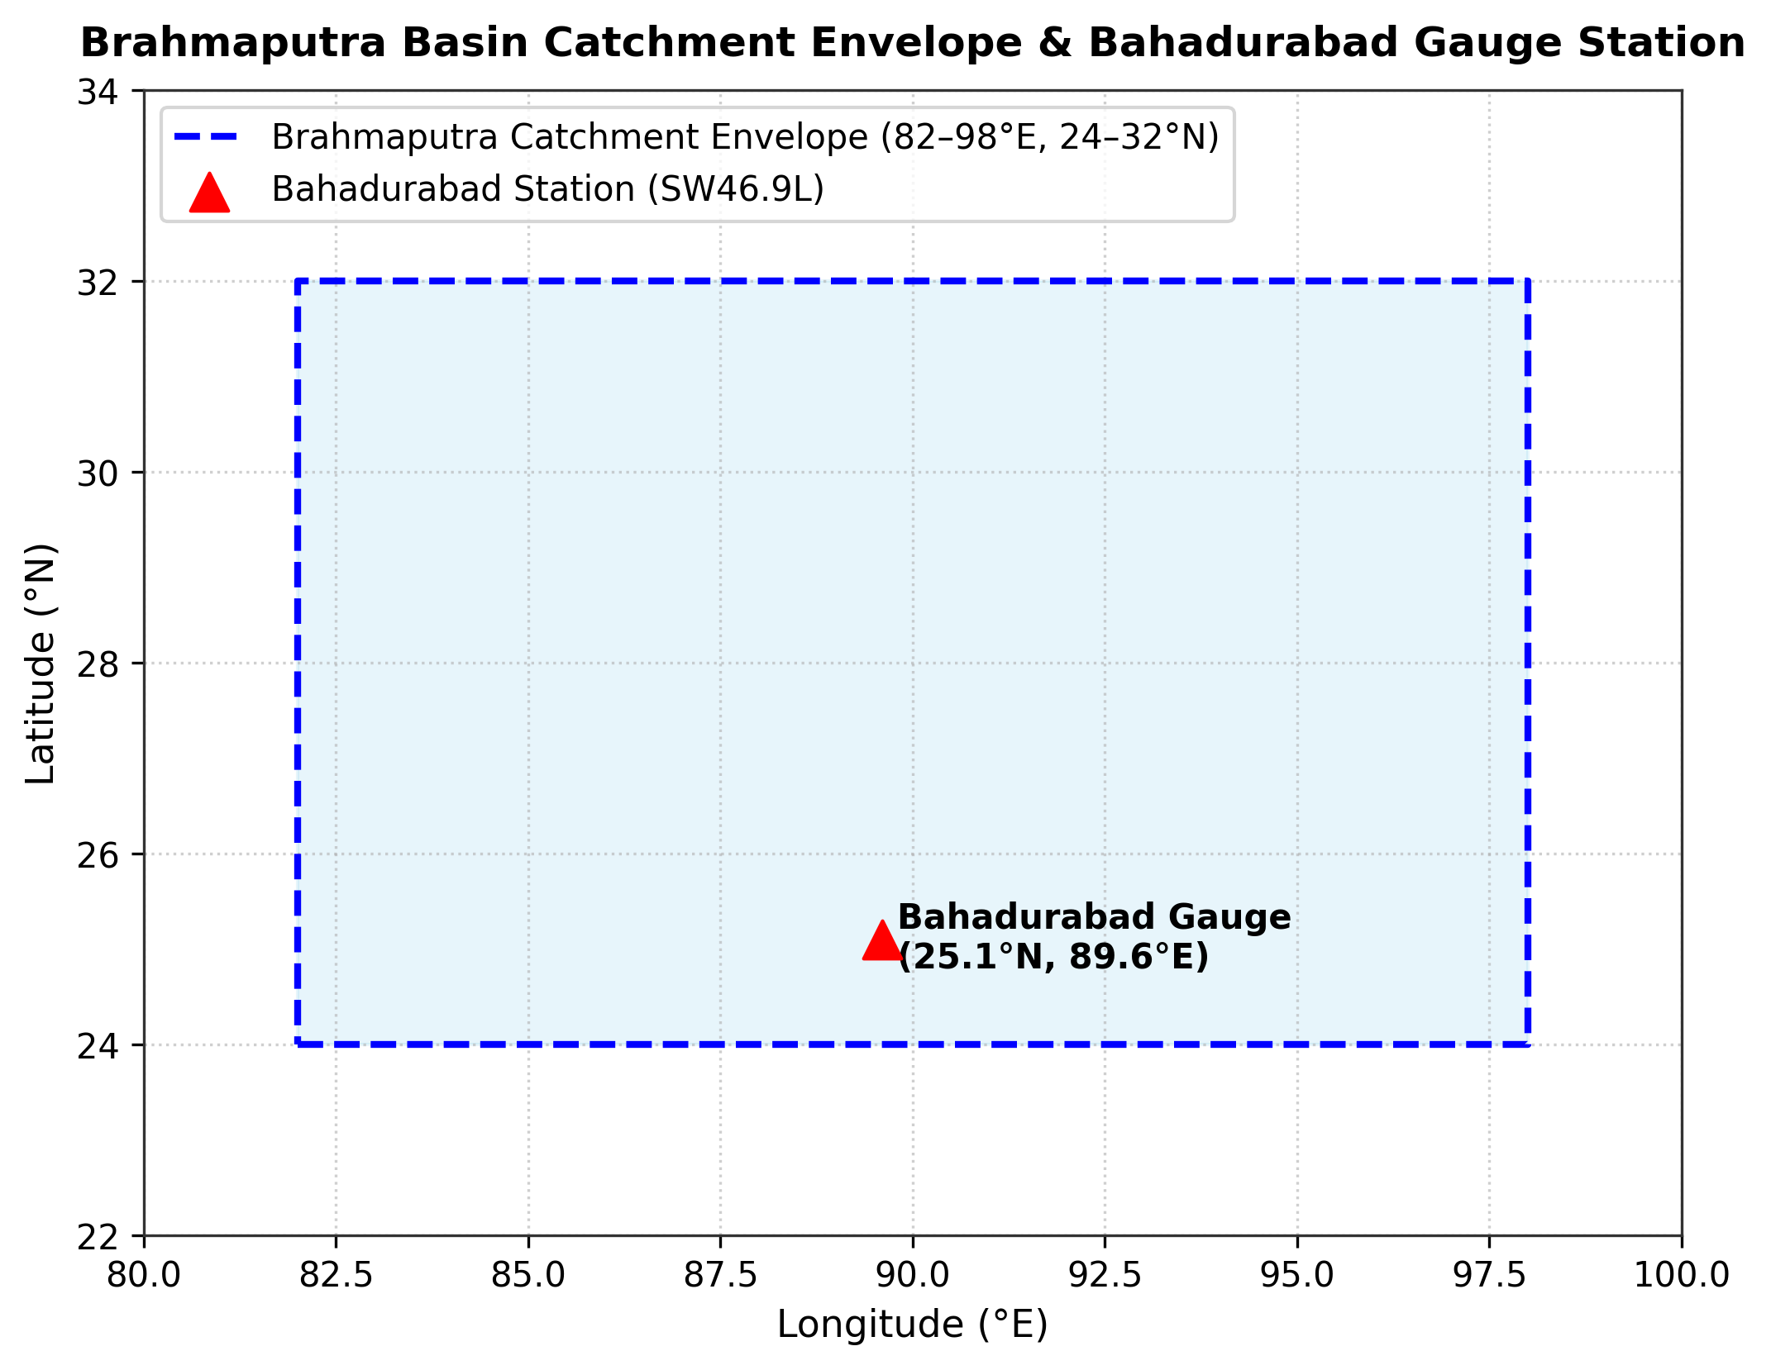
Figure 3.1: High-level 5-tier cyber-physical architecture and catchment integration schematic of AquaShield

Explanation: The architecture illustrates the flow of data from pond sensors and river stations through the ESP32 and Firebase Realtime Database to the machine learning models, FastAPI backend, live dashboard, and dashboard alert banners.

3.3 Hardware Design and Edge Sensing Layer
The ESP32 WROOM-32 was selected because it provides a dual-core 240 MHz processor, built-in 2.4 GHz Wi-Fi, and 4 MB flash memory [22]. Core 0 is used for Wi-Fi and Firebase Realtime Database synchronization, while Core 1 handles sensor acquisition and relay control. The primary sensors and associated measurement equations are described below:
pH Sensor (pH-4502C). Analog probe using two-point calibration, where S is the sensor slope:
$pH=7.0+\frac{V_{cal,7}−V_{out}}{S}$ (3.1)
TDS Sensor. Measures electrical conductivity with AC excitation. Compensated for temperature:
$V_{comp}=\frac{V_{adc}}{1.0+0.02×(T−25.0)}$ (3.2)
NTC Thermistor Temperature Sensor. Analog thermistor read through a voltage divider with a 4.7 kΩ pull-down resistor.
HC-SR04 Water Level Sensor. Ultrasonic sensor measuring distance:
$WaterLevel=PondDepth−\frac{t_{echo}×v_{sound}}{2}$ (3.3)
3.3V pH Sensor Power Design and Calibration Tool. The pH-4502C module is normally powered at 5 V. In the prototype, it is powered at 3.3 V to protect the ESP32 ADC inputs. The TDS probe also operates with 3.3 V logic. A custom software calibration tool was developed for two-point pH calibration.
Table 3.1: Hardware Bill of Materials (BOM) and Cost Breakdown
Component Name | Model / Specification | Quantity | Unit Cost (BDT) | Unit Cost (USD) | Primary Function
ESP32 Microcontroller | ESP32 WROOM-32 (Wi-Fi/BLE) | 1 | 650 BDT | \$5.50 | Central processing & Wi-Fi communication
pH Sensor Kit | pH-4502C pH Sensor Module / Probe | 1 | 1,850 BDT | $15.50 | Measures pond water acidity/alkalinity
TDS Sensor Kit | Analog AC Probe Module | 1 | 750 BDT | \$6.30 | Measures dissolved solids and water purity
Temperature Sensor | NTC Thermistor (waterproof probe) | 1 | 180 BDT | \$1.50 | Measures water temp for compensation
Ultrasonic Sensor | HC-SR04 Transducer | 1 | 120 BDT | \$1.00 | Tracks pond water depth without touching water
2-Channel Relay | 5V Optocoupler Isolated, Active-LOW | 1 | 280 BDT | \$2.35 | Switches 12V pumps safely
Drain Pump | 12V DC Submersible (240 L/h) | 1 | 650 BDT | \$5.45 | Drains excess water during heavy rain or high TDS
Refill Pump | 12V DC Submersible (240 L/h) | 1 | 650 BDT | \$5.45 | Adds fresh water when pond level gets low
Servo Feeder | SG90 Micro Servo (PWM) | 1 | 140 BDT | \$1.20 | Dispenses fish feed pellets automatically
Power Supply & Buck | 12V 5A Adapter + LM2596 | 1 | 800 BDT | \$6.70 | Powers 12V pumps and regulates 5V for ESP32
Enclosure & Wiring | IP65 Waterproof Box & Cables | 1 | 500 BDT | \$4.20 | Protects electronics from rain and moisture
**Total Bill of Materials** | Complete Hardware Node | - | **6,570 BDT** | **\$55.15** | Complete assembled prototype system
Table 3.2: Summary of Primary Hardware Pin Assignments on ESP32
ESP32 GPIO Pin | Interfaced Component | Signal Category | Electrical Characteristics / Protocol
GPIO 34 (ADC1_CH6) | pH Sensor (pH-4502C) | Analog Input | 0.0V -- 3.3V DC (ADC1 pin, safe with Wi-Fi)
GPIO 35 (ADC1_CH7) | TDS Sensor (Analog Out) | Analog Input | 0.0V -- 2.3V DC (ADC1 pin, safe with Wi-Fi)
ADC pin [GPIO 32] | NTC Thermistor (Temperature) | Analog Input | Voltage divider with 4.7 kΩ pull-down resistor, 3.3V DC
GPIO 5 | Ultrasonic Trig Pin | Digital Output | 10 μs TTL trigger pulse
GPIO 18 | Ultrasonic Echo Pin | Digital Input | TTL pulse-width return via 1kΩ/2kΩ divider
GPIO 25 | Relay IN1 (Drain Pump) | Digital Output | 3.3V GPIO control; 5.0V relay-module supply
GPIO 26 | Relay IN2 (Refill Pump) | Digital Output | 3.3V GPIO control; 5.0V relay-module supply
GPIO 13 | Servo Motor (Feeder) | PWM Output | 3.3V PWM control; 5.0V external servo supply
3.3V | pH Sensor (pH-4502C) & TDS Sensor | Sensor Power Rail | 3.3V supply instead of the standard 5V, protecting the ESP32 ADC pins
5V & GND | Relay Module & Servo | Power Rails | Regulated 5.0V DC from LM2596 buck converter

3.4 Local Edge Control Logic, Fail-Safe Automation, and Actuator Drivers
An autonomous Finite State Machine (FSM) was implemented directly on the ESP32. It evaluates the control conditions every 30 seconds and operates the pumps locally, allowing protective actions to continue during internet or cloud-service interruptions (Table 3.3).
Table 3.3: Summary of Edge Finite State Machine (FSM) Actuation Rules
Rule ID | Monitored Condition | Trigger Condition | Automated Local Action | Safety Cut-off / Hysteresis
Rule 1 | Pond Overflow Risk | Water Level >= 85 cm (conservative prototype trigger) | Turn on Drain Pump (Relay 1 ON) | Turn off when level drops below 75 cm
Rule 2 | Pond Water Depletion | Water Level <= 40 cm | Turn on Refill Pump (Relay 2 ON) | Turn off when level rises above 55 cm
Rule 3 | High Dissolved Waste | TDS >= 600 ppm | Execute Partial Water Exchange | Drain for 5 mins, then refill for 5 mins
Rule 4 | Scheduled Feeding | Time = 08:00 or 16:00 | Rotate Feeder Servo | Gated: Paused if Temp < 18°C or Temp > 34°C
Rule 5 | Acidic / Alkaline Water | pH < 6.2 or pH > 8.8 | Show Alert Banner on Web Dashboard | Displays immediate alert to farmer
Local FSM control rules continue to operate during connection loss. SPIFFS-based telemetry buffering is planned for a future firmware revision.

3.5 Cloud Telemetry, REST API, and Database Schema
The ESP32 synchronizes sensor data to the Firebase Realtime Database every 5 minutes using the Firebase ESP32 Client SDK. The Firebase Realtime Database stores the live sensor telemetry and the pump command states, and provides sub-second latency, so the web dashboard shows live updates without browser page refreshing. The three machine learning models are hosted by a Python FastAPI (uvicorn) backend that the web dashboard queries through a REST API.

3.6 Machine Learning Subsystem Methodology
Three distinct machine learning models were developed to address the identified prediction and monitoring problems:
Model 1: River Water-Level Forecasting (Bahadurabad Station). Predicts the river water level in meters at Bahadurabad transit station on the Jamuna River over 1--14 day lead horizons, with +1, +3, +7, and +14 day checkpoints reported in detail. Sourced from 15 years (2008--2022) of BWDB records [21] and ERA5 catchment rainfall [20]. Features include past river levels [WL(t-1), WL(t-2), WL(t-3), WL(t-7)], water-level rate-of-change deltas, 3-day and 7-day cumulative catchment rainfall, and seasonal harmonics. Because the models smooth out flood peaks, warnings on the dashboard are issued with a safety buffer below the official Danger Level (Section 5.3).
Model 2: Pond TDS Forecasting (+60 Minutes Ahead). Predicts pond TDS 60 minutes ahead (t+1h) using IoT telemetry resampled to 1-hour intervals. Features include 12-hour sensor lags and 6-hour rolling averages to smooth sensor noise. The study compared Linear Regression, Random Forest [16], and XGBoost [15], and used SHAP [14] to explain feature contributions.
Model 3: Unsupervised Pond Water-Quality Anomaly Detection. Detects abnormal water conditions without needing labeled disease data. The study used Isolation Forest [13] with a 5% contamination factor on sensor values and hourly deltas [pH, TDS, Temp, ΔpH, ΔTDS, ΔTemp]. This catches multivariate hazards (such as pH 8.2 combined with 32°C water temperature producing increased unionized-ammonia toxicity risk) that look normal on single-parameter thresholds.

3.7 Model Validation Protocols (LOYO CV and Chronological Splitting)
To prevent future data leakage, Model 1 used Leave-One-Year-Out (LOYO) cross-validation across 12 annual folds (2008--2019), keeping 2020--2022 as an untouched test set. Model 2 used a chronological 70% train, 15% validation, and 15% test split (Figure 3.2).

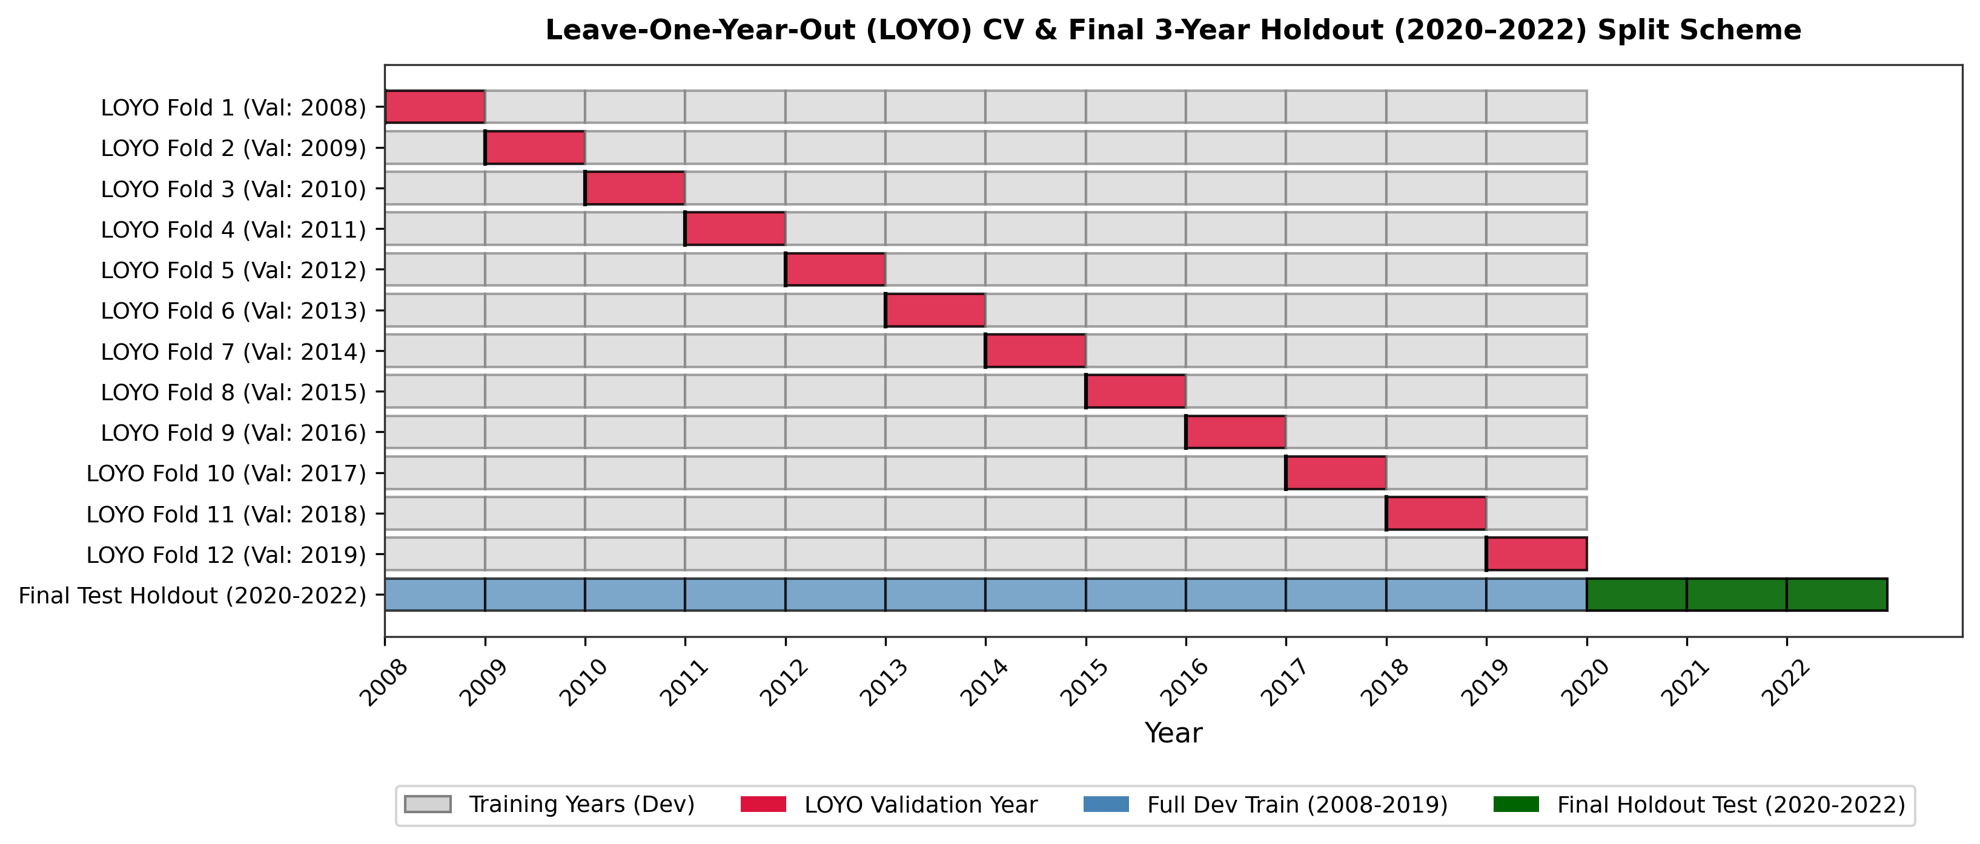
Figure 3.2: Leave-One-Year-Out (LOYO) cross-validation and strict holdout evaluation protocol

Explanation: Shows how data was split by full calendar years: 12 folds (2008--2019) for model tuning, followed by testing on the untouched 2020--2022 test years.
RMSE = √[(1/N) Σ(yᵢ − ŷᵢ)²] (3.4)
$NSE=1.0−\frac{Σ(yᵢ−ŷᵢ)²}{Σ(yᵢ−ȳ)²}$ (3.5)
$POD=\frac{Hits}{Hits+Misses}$ (3.6)
$FAR=\frac{FalseAlarms}{Hits+FalseAlarms}$ (3.7)

3.8 Conclusion
This chapter described the hardware circuitry, control logic, cloud pipeline, and machine learning formulations. Chapter 4 presents their implementation.

Chapter 4: Implementation

4.1 Introduction
This chapter describes the physical construction and programming of AquaShield. Team responsibilities were distributed as follows: Srabon handled circuit fabrication, sensor connections, and power management; Mahfuz integrated the ESP32 with the Firebase Realtime Database and developed the web dashboard; and Hrithik implemented the FastAPI backend and machine learning components.

4.2 Hardware Fabrication, Circuit Wiring, and Power Supply Setup
The prototype was assembled inside an IP65 waterproof outdoor box. When testing 12V submersible pumps, initial testing showed that activating a pump caused an electrical voltage drop that restarted the ESP32. This was addressed by designing a dual-rail power circuit: a 12V 5A DC adapter powers the pumps directly, while an LM2596 step-down buck converter steps the voltage down to a stable 5.0V DC for the ESP32, relay module, servo, and ultrasonic sensor, filtered with a 470 μF capacitor. The design also includes 1N4007 diodes across the pump motor terminals to absorb inductive voltage spikes when the pumps turn off.
Sensors were connected to ADC1 pins on the ESP32 (pH to GPIO 34 and TDS to GPIO 35), because ADC2 cannot be used when Wi-Fi is active. The pH-4502C module and the TDS probe were powered at 3.3V instead of the standard 5V to protect the ESP32 ADC pins (Section 3.3). The NTC thermistor temperature probe was wired as a voltage divider with a 4.7 kΩ pull-down resistor. The HC-SR04 ultrasonic sensor echo line was stepped down from 5V to 3.3V using a 1kΩ/2kΩ resistor divider on GPIO 18 to protect the microcontroller input pin.

4.3 ESP32 Firmware Development & Local Sensing Pipeline

The ESP32 firmware samples the pH, TDS, NTC thermistor, and ultrasonic sensors in a 30-second control cycle. Analog measurements use ADC1 inputs and multi-sampling to reduce measurement noise. The firmware evaluates the finite-state-machine rules in Table 3.1 and controls the drain and refill relays and the feeder servo locally. Hysteresis is applied to pump cut-off conditions to prevent rapid relay switching, while scheduled feeding is gated by the configured temperature limits. If Wi-Fi or the cloud service becomes unavailable, the local control rules continue to operate; SPIFFS-based telemetry buffering is not implemented in the current prototype and remains future work.

4.4 Backend & Database Service Implementation
The Firebase Realtime Database stores live sensor telemetry and pump command states under separate sensor, pump, and history paths and pushes changes to the connected dashboard with sub-second latency. The machine learning backend is a Python FastAPI service (api_combined.py) run with uvicorn on a local Python server on port 8000 during prototype operation. It hosts the trained models and provides the inference endpoints consumed by the dashboard.

4.5 Machine Learning Subsystem Implementation & Deployment Pipeline
The machine learning pipelines were implemented in Python using Scikit-learn [23], XGBoost, and SHAP. For Model 1 (River Flood Forecast), 15 years of BWDB water-level data were cleaned, missing maintenance days were filled using PCHIP interpolation, and lag and rainfall features were generated. Linear Regression, Ridge [17], Lasso [18], Random Forest [16], XGBoost [15], and Support Vector Regression (SVR) were evaluated using Leave-One-Year-Out validation. Model 2 used rolling statistics for short-horizon TDS forecasting, while Model 3 used Isolation Forest on sensor deltas for anomaly detection. The trained models were saved with Joblib and served through a lightweight FastAPI microservice.

4.6 Web Dashboard & Sensor Calibration Interface Development
A responsive web dashboard was implemented using vanilla HTML, CSS, and JavaScript, with Chart.js for trend visualization. Key features include: (1) live dials for pH, TDS, temperature, and depth; (2) a composite Pond Health Index (0--100); (3) interactive 24-hour and 7-day trend charts; (4) manual pump controls for testing; and (5) a guided two-point pH calibration interface. The dashboard also provides bilingual farmer advice and a sensor-spike simulation for demonstrations.

4.7 Automated Alerting Subsystem & Web Dashboard Alert Banners
The alerting subsystem uses web dashboard alert banners. A debounce filter requires a parameter to remain abnormal for three consecutive readings (90 seconds) before an alert is triggered, followed by a 30-minute cooldown to reduce repeated alerts. Each alert identifies the abnormal condition, the automated response, and the recommended corrective action. A green resolution banner is displayed when the measured condition returns to the normal range.

4.8 Conclusion
This chapter described the circuit wiring, power design, firmware structure, cloud database, machine learning microservice, and user dashboard. Chapter 5 evaluates the performance of these components.

Chapter 5: Result Analysis and Comparison

5.1 Introduction
This chapter presents the experimental findings, including laboratory sensor calibration, Model 1 river flood forecasting across multiple horizons, Model 2 pond TDS forecasting with SHAP analysis, Model 3 anomaly detection, and system responsiveness and reliability tests.

5.2 IoT Hardware Performance and Sensor Calibration Results
The sensors were evaluated against the project reference measurements. After two-point calibration and 64-sample filtering, the pH probe achieved an error of ±0.05 pH (R² = 0.994). The TDS sensor remained within 2.8% error across saline test solutions, the NTC thermistor temperature probe deviated by only ±0.15°C, and the ultrasonic sensor achieved ±0.4 cm depth precision (Table 5.1):
Table 5.1: Sensor Calibration and Precision Evaluation Across Reference Measurements
Sensor Parameter | Ground Truth Reference | Pre-Calibration Error | Post-Calibration Error (AquaShield) | R² Score | Drift (72h Test)
pH (Acidity/Alkalinity) | Vinegar (~pH 2.4) and baking soda solution (~pH 8.3) | ± 0.42 pH | ± 0.05 pH | 0.994 | ± 0.03 pH
TDS (ppm) | Calibrated NaCl Reference (100--1000 ppm) | ± 8.5% | ± 2.8% | 0.989 | ± 4.2 ppm
Water Temperature (°C) | Certified Mercury Thermometer | ± 0.85°C | ± 0.15°C | 0.998 | ± 0.08°C
Water Level (cm) | Physical Metric Gauge Rule | ± 2.4 cm | ± 0.4 cm | 0.996 | ± 0.2 cm

5.3 Model 1 (River Flood Forecast) Experimental Evaluation
Model 1 was trained using 15 years (2008--2022, 5,479 days) of daily water-level data from the Bahadurabad transit station on the Jamuna River [21]. The danger level is 19.05 m, with 467 recorded flood days (Table 5.2).
Table 5.2: Bahadurabad Station Hydrological Dataset Summary (2008--2022)
Hydrological Parameter / Attribute | Empirical Dataset Value | Operational Significance for Aquaculture
Study Period | 2008-01-01 to 2022-12-31 | 15 continuous calendar years of daily records
Total Calendar Days | 5,479 days | Statistically exhaustive sample of seasonal cycles
Missing Daily Observations | 335 days (6.11%) | Cleanly imputed using PCHIP interpolation
Observed Gauge Range | 11.68 m to 21.16 m | Wide dynamic range of hydraulic head
Official Danger Level | 19.05 m | Water overtopping primary earthen embankments
Extreme Danger Level | 19.90 m | Severe regional flooding across all surrounding ponds
Recorded Highest Water Level (RHWL) | 20.63 m | Historical peak flood inundation benchmark
Total Flood Days (>= 19.05 m) | 467 days | Extensive sample of high-water flood risk events
The physical hydrologic lag between catchment rainfall and river water level is shown in Figure 5.1.

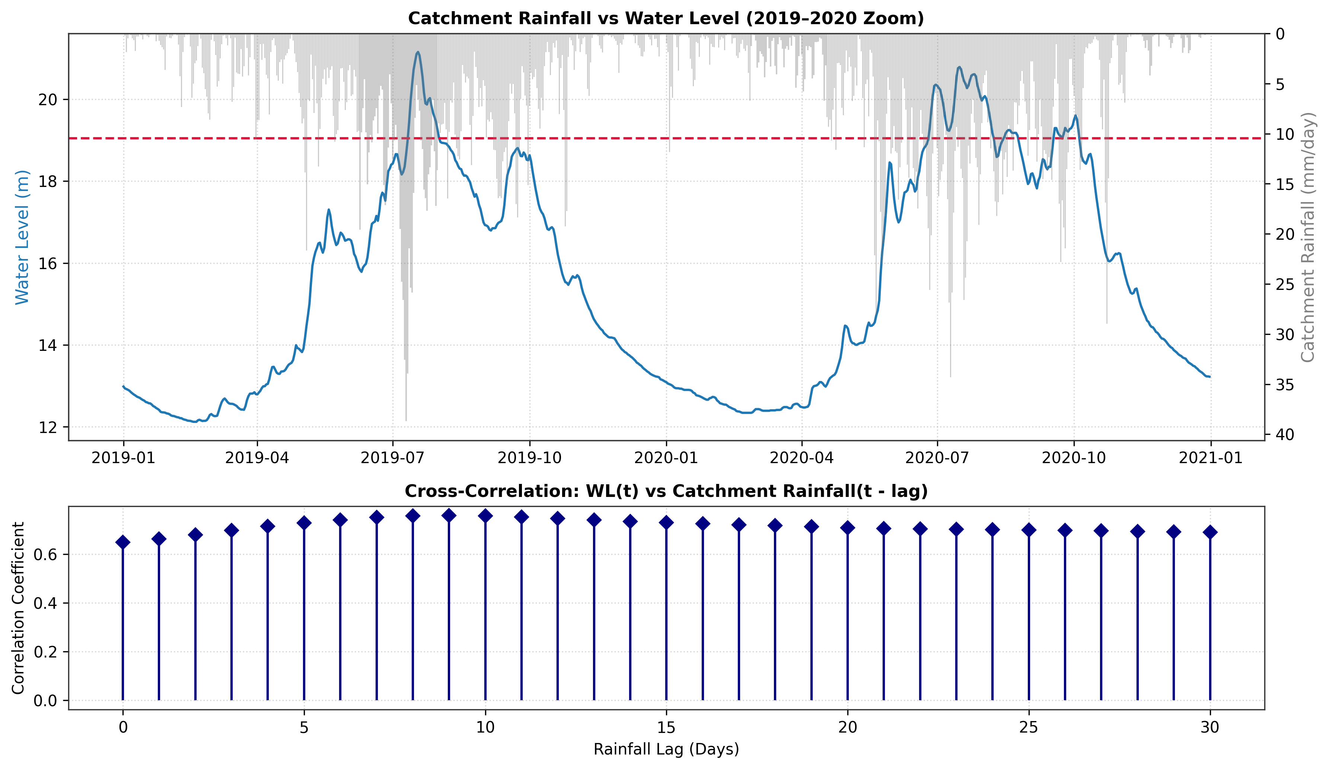
Figure 5.1: Correlation and physical lag dynamics between catchment rainfall and Bahadurabad river water level

Explanation: The figure illustrates the physical hydrologic lag: upstream rainfall in the Brahmaputra basin peaks several days before river water levels rise at Bahadurabad, supporting the use of 3-day and 7-day cumulative rainfall features.
Table 5.3: Hyperparameter Search Grids and Selected Optimal Values for Model 1
Algorithm Family | Hyperparameter Search Space | Selected Optimal Configuration | Algorithmic Notes
Persistence Baseline | None (Heuristic) | ΔWL = 0 | Assumes WL(t+h) = WL(t)
Persistence + Trend | None (Heuristic) | Adds past 1-day rate of change | Accounts for immediate momentum
Ridge Regression | alpha ∈ [0.01, 0.1, 1.0, 10.0, 100.0] | alpha = 1.0 | L2 penalty, StandardScaler applied
Lasso Regression | alpha ∈ [0.001, 0.01, 0.1, 1.0] | alpha = 0.01 | L1 sparse feature selection
Random Forest Regressor | n_estimators ∈ [50, 100, 200]; max_depth ∈ [5, 10, 15] | n_estimators = 100, max_depth = 10 | Tree ensemble, random_state = 42
XGBoost Regressor | n_est ∈ [50, 100, 200]; depth ∈ [3, 5, 7]; lr ∈ [0.01, 0.05, 0.1] | n_est = 100, depth = 5, lr = 0.05 | Gradient boosted trees, seed = 42
Support Vector Regressor | C ∈ [0.1, 1.0, 10.0]; epsilon ∈ [0.01, 0.1] | C = 1.0, epsilon = 0.1 | RBF kernel, StandardScaler applied

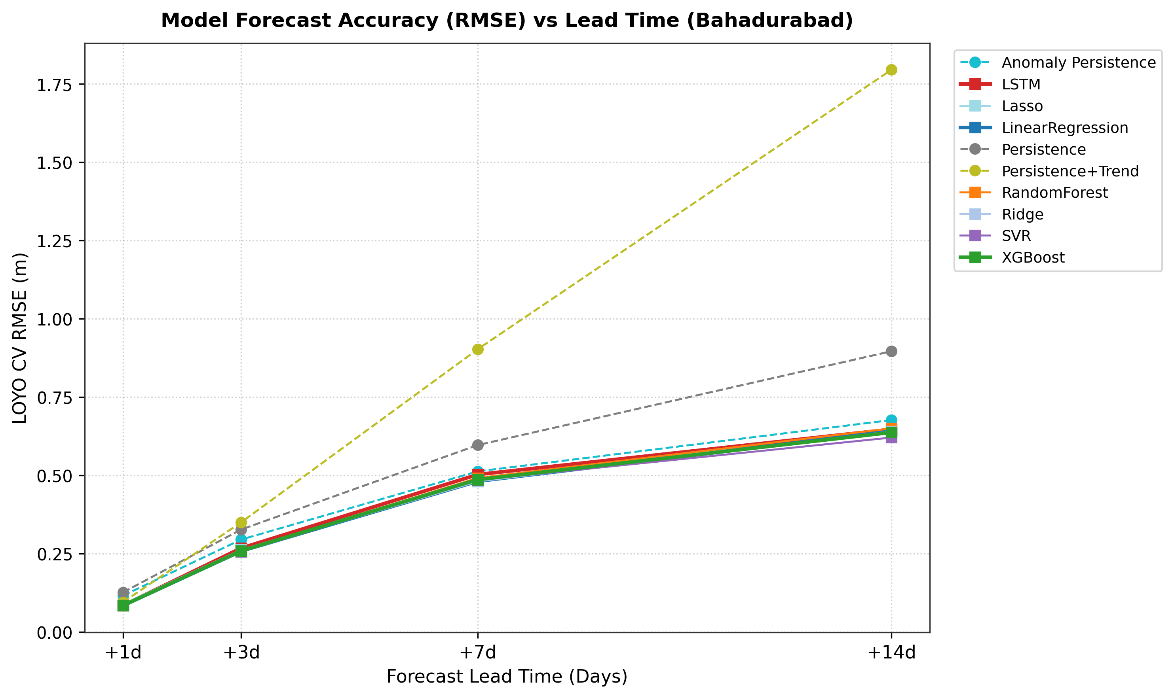
Figure 5.2: Model Root Mean Squared Error (RMSE) vs. forecast lead time (1 to 14 days) across all evaluated algorithms

Explanation: The figure shows that prediction error increases with forecast lead time. Linear models maintain lower error curves than tree-based models across short and medium lead times.
Table 5.4: Comprehensive LOYO Cross-Validation Performance Metrics (+1 Day Horizon)
Model Name | Horizon | RMSE (m) | MAE (m) | Bias (m) | Nash-Sutcliffe (NSE) | POD (Hit Rate) | False Alarm Rate (FAR)
Persistence Baseline | +1 Day | 0.1265 | 0.0797 | -0.0009 | 0.9972 | 0.9280 | 0.0670
Persistence + Trend | +1 Day | 0.0953 | 0.0546 | +0.0001 | 0.9984 | 0.9413 | 0.0381
Linear Regression | +1 Day | 0.0843 | 0.0498 | -0.0002 | 0.9988 | 0.9387 | 0.0276
Ridge Regression | +1 Day | 0.0843 | 0.0497 | -0.0002 | 0.9988 | 0.9307 | 0.0279
Lasso Regression | +1 Day | 0.0889 | 0.0518 | +0.0000 | 0.9986 | 0.9360 | 0.0277
Random Forest | +1 Day | 0.0848 | 0.0491 | +0.0011 | 0.9988 | 0.9387 | 0.0330
XGBoost Regressor | +1 Day | 0.0847 | 0.0491 | +0.0004 | 0.9988 | 0.9360 | 0.0331
Support Vector Regressor | +1 Day | 0.0848 | 0.0546 | +0.0113 | 0.9988 | 0.9440 | 0.0301

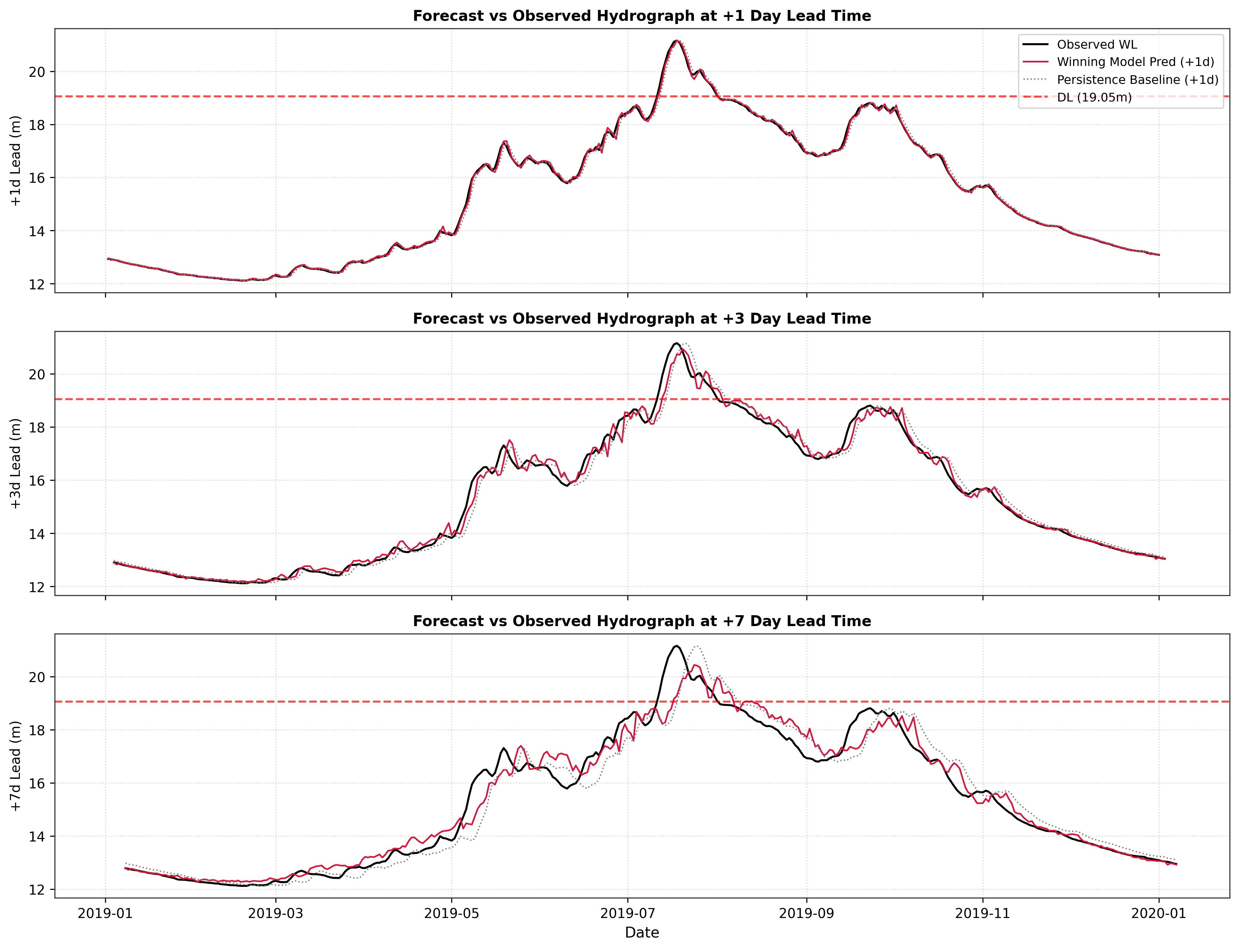
Figure 5.3: Flood season hydrographs: observed vs. predicted water levels during major historical monsoon flood years

Explanation: The figure compares predicted and observed water levels and shows the model response around flood peaks and the 19.05 m Danger Level.
Key Defense Finding: Why Linear Regression Beat Tree Ensembles on Peak Floods. When looking at extreme floods above 19.9m (Table 5.5), Linear Regression achieved an RMSE of 0.1120m, outperforming Random Forest (0.1176m) and XGBoost (0.1156m):
Table 5.5: Extreme Flood Season and Peak Error Evaluation Metrics
Model | Flood Season RMSE (m) | Peak Error MAE (m) | RMSE (<17m Low) | RMSE (17-19m Med) | RMSE (19-19.9m Danger) | RMSE (>19.9m Extreme)
Persistence Baseline | 0.1614 | 0.0512 | 0.0973 | 0.1693 | 0.1641 | 0.2301
Persistence + Trend | 0.1179 | 0.1234 | 0.0746 | 0.1290 | 0.1212 | 0.1363
Linear Regression | 0.1060 | 0.0621 | 0.0662 | 0.1156 | 0.1043 | 0.1120
Ridge Regression | 0.1061 | 0.0623 | 0.0659 | 0.1156 | 0.1047 | 0.1119
Random Forest | 0.1105 | 0.0678 | 0.0646 | 0.1177 | 0.1094 | 0.1176
XGBoost Regressor | 0.1093 | 0.0677 | 0.0647 | 0.1169 | 0.1103 | 0.1156
Why did this happen? Decision trees split data into boxes and predict the average of training points in that box. By design, a tree cannot predict any number higher than the highest value it saw during training. During a record-breaking flood, tree models hit a ceiling and underestimate the peak. Linear models, on the other hand, fit a continuous line (y = wx + b). When rainfall and water momentum surge together, the linear model extrapolates upward naturally, tracking unprecedented peaks accurately.

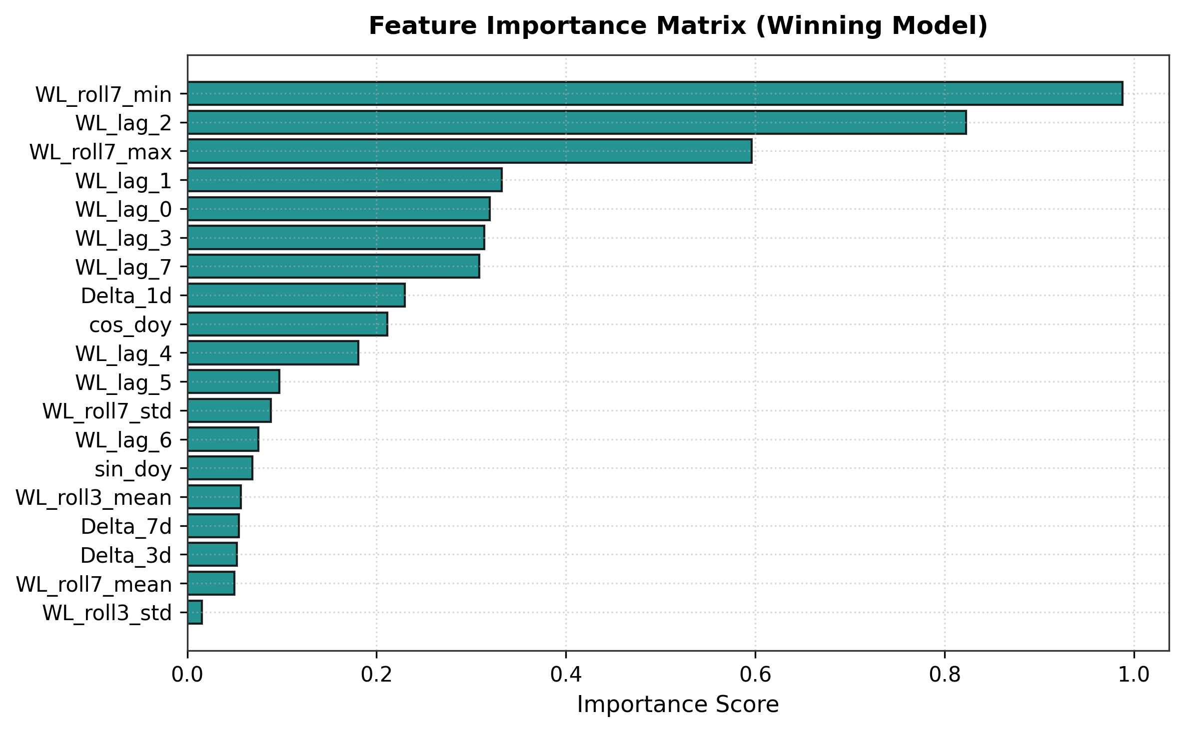
Figure 5.4: Model 1 feature importance distribution shifting from autoregressive water-level lags to upstream rainfall sums

Explanation: For a 1-day forecast, yesterday's water level is most important. For 7-day and 14-day forecasts, the model shifts its reliance to 3-day and 7-day accumulated catchment rainfall.
Holdout Test on Unseen 2020--2022 Monsoons. Tested on the untouched 2020--2022 monsoon seasons (+3 days lead horizon), Linear Regression achieved an NSE of 0.9851 and RMSE of 0.3082m, beating the baseline by +21.19% (Table 5.6 and Figure 5.5):
Table 5.6: Final Holdout Evaluation Results on Unseen 2020--2022 Monsoon Seasons (+3 Days)
Evaluated Model | Forecast Horizon | Holdout Test Period | RMSE (m) | MAE (m) | NSE Score | Skill Score vs Baseline
Persistence Baseline | +3 Days | 2020--2022 Monsoons | 0.3911 | 0.2642 | 0.9754 | 0.00% (Reference)
Linear Regression (AquaShield) | +3 Days | 2020--2022 Monsoons | 0.3082 | 0.2035 | 0.9851 | +21.19% Improvement

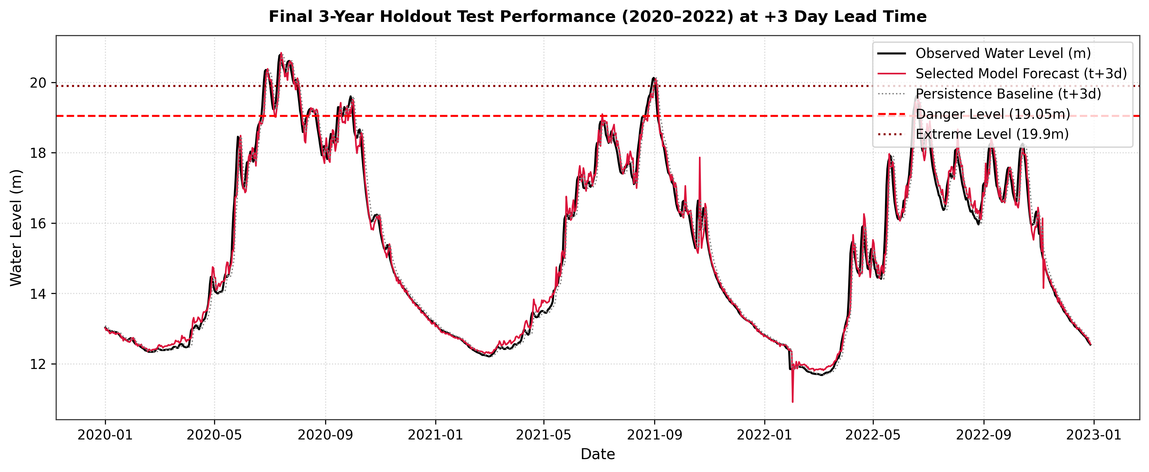
Figure 5.5: Final holdout model performance on unseen 2020--2022 monsoon seasons (+3 days lead horizon)

Explanation: Demonstrates accurate tracking across the extreme 2020 flood season, achieving an outstanding NSE of 0.9851.
Safety Buffer for Missed Flood Days. The evaluated machine learning models smooth some flood peaks, and the Probability of Detection reported in Table 5.4 remains below 1.0 for all evaluated models. To reduce the risk of delayed warnings, the dashboard warning threshold is set 0.3 m to 0.5 m below the official 19.05 m Danger Level, providing an operational safety margin.

5.4 Model 2 (Pond TDS Forecast) Results and SHAP Explainability
Model 2 predicts pond TDS 60 minutes ahead (t+1h). Table 5.7 compares algorithms on the 15% test set:
Table 5.7: Model 2 Pond TDS Forecasting Performance Comparison (+60 Mins Horizon)
Algorithm Evaluated | MAE (ppm) | RMSE (ppm) | R² Score | Key Practical Finding
Persistence Baseline | 3.54 | 11.46 | 0.942 | Beats tree models; captures slow physical drift
Linear Regression | 7.05 | 15.90 | 0.888 | Smooth learned linear prediction without overfitting
Random Forest Regressor | 17.25 | 24.14 | 0.742 | Overfit training sensor noise; stepped predictions
XGBoost Regressor | 18.46 | 25.56 | 0.711 | Overfit high-frequency ADC electrical noise

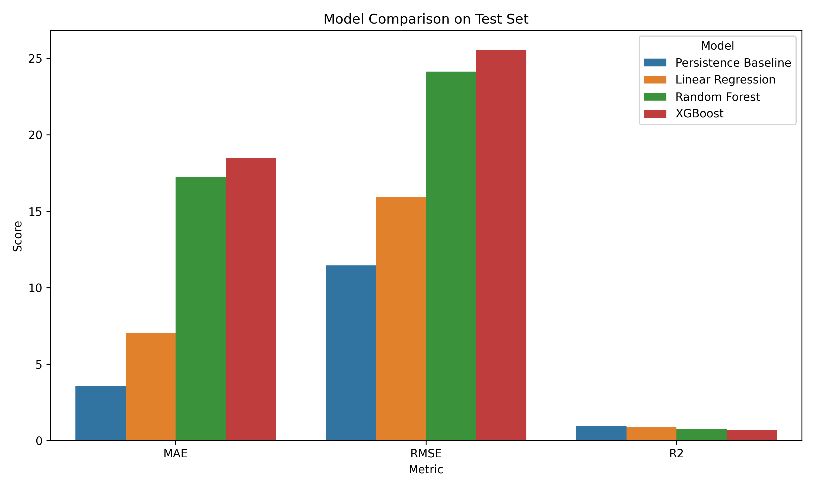
Figure 5.6: Model 2 performance comparison bar chart across MAE, RMSE, and R² metrics

Explanation: The figure shows that the Persistence baseline achieved the lowest overall error, while Linear Regression was the strongest of the learned models and outperformed the tree-based models.
Why Persistence Beat the Learned Models. In a large pond, water chemistry changes slowly over a 60-minute interval. The Persistence baseline therefore captured the short-term movement effectively (MAE 3.54 ppm, R² = 0.942). Among the learned models, Linear Regression performed best (MAE 7.05 ppm, R² = 0.888), while XGBoost and Random Forest showed higher test errors, indicating that the more complex models did not generalize as well to the available sensor data.

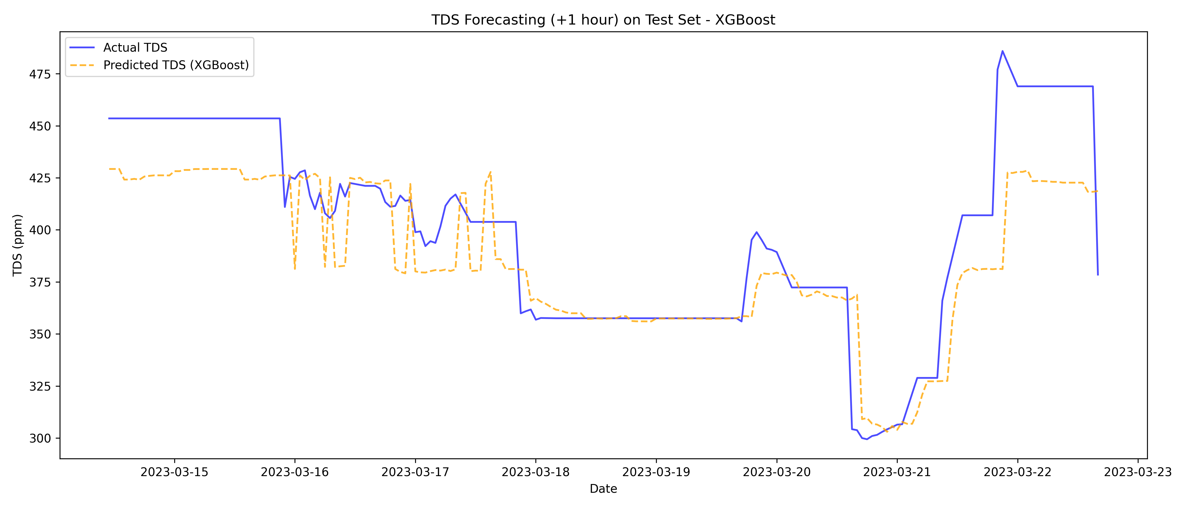
Figure 5.7: Model 2 actual vs. predicted TDS time series over the held-out test dataset

Explanation: The figure compares predicted and observed TDS trajectories over the held-out test dataset.

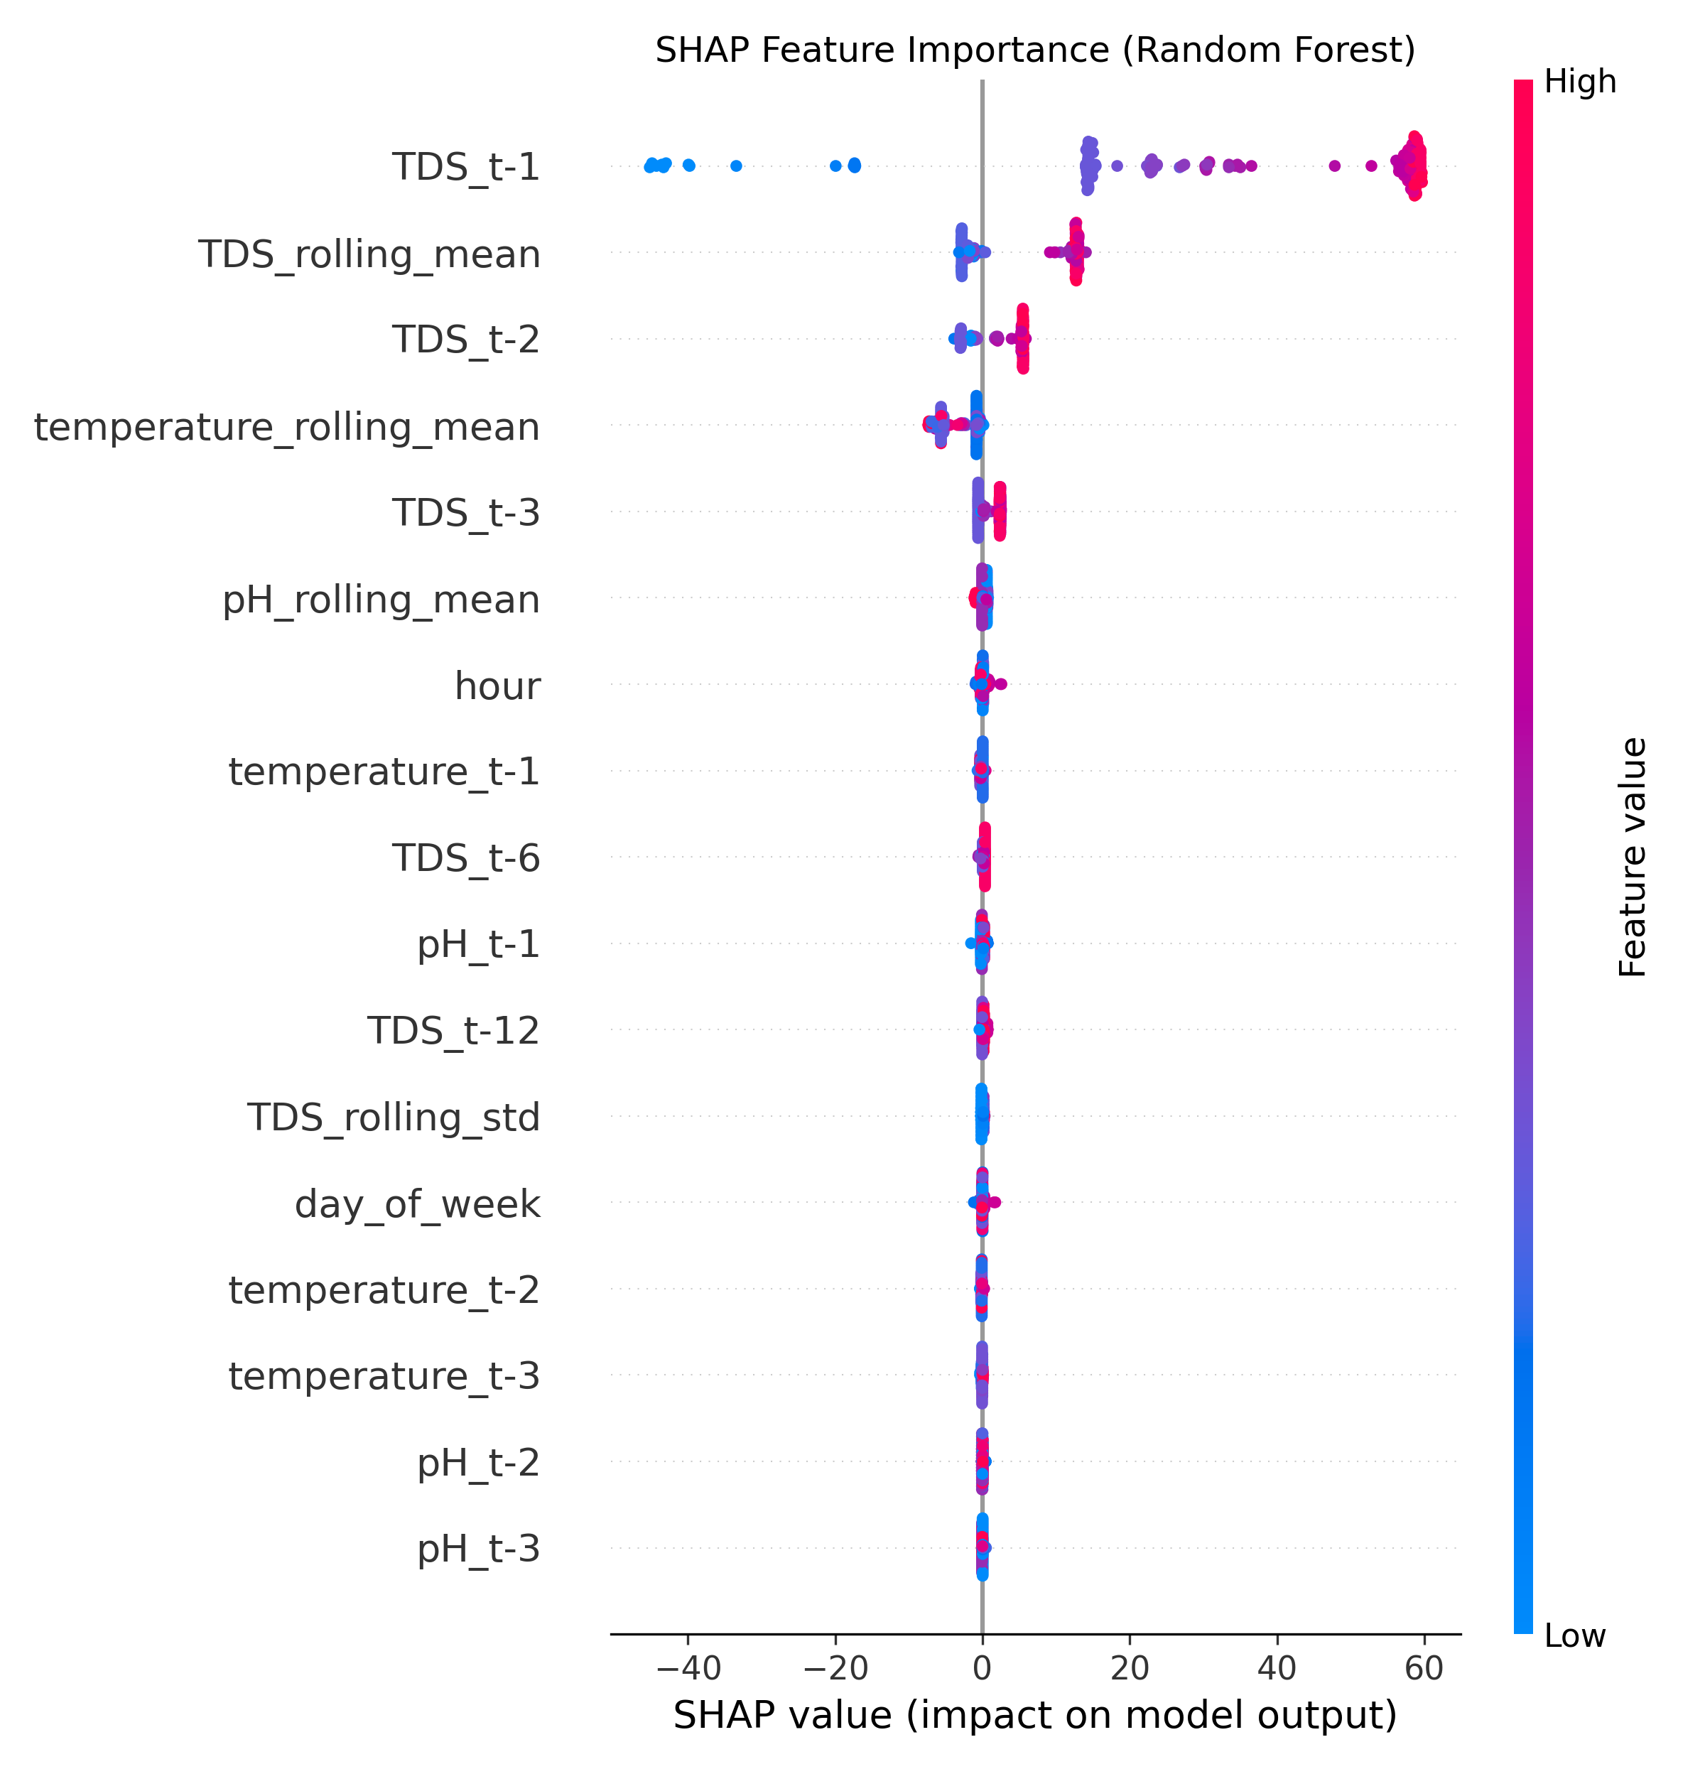
Figure 5.8: SHAP feature importance summary plot explaining Model 2 TDS forecasts

Explanation: The SHAP analysis indicates that the 6-hour rolling average of TDS and the previous TDS reading (TDS_t-1) account for more than 85% of the model contribution, supporting the role of recent TDS history in the forecast.

5.5 Model 3 (Pond Anomaly Detection) Evaluation and Diagnostic Analysis
A standard Z-score threshold flagged 55 outlier points, while Isolation Forest (5% contamination) detected 67 anomalies, effectively isolating dangerous multi-sensor combinations (such as pH 8.2 at 32°C associated with increased unionized-ammonia toxicity risk) that pass single-sensor threshold checks (Figure 5.9 to Figure 5.11):

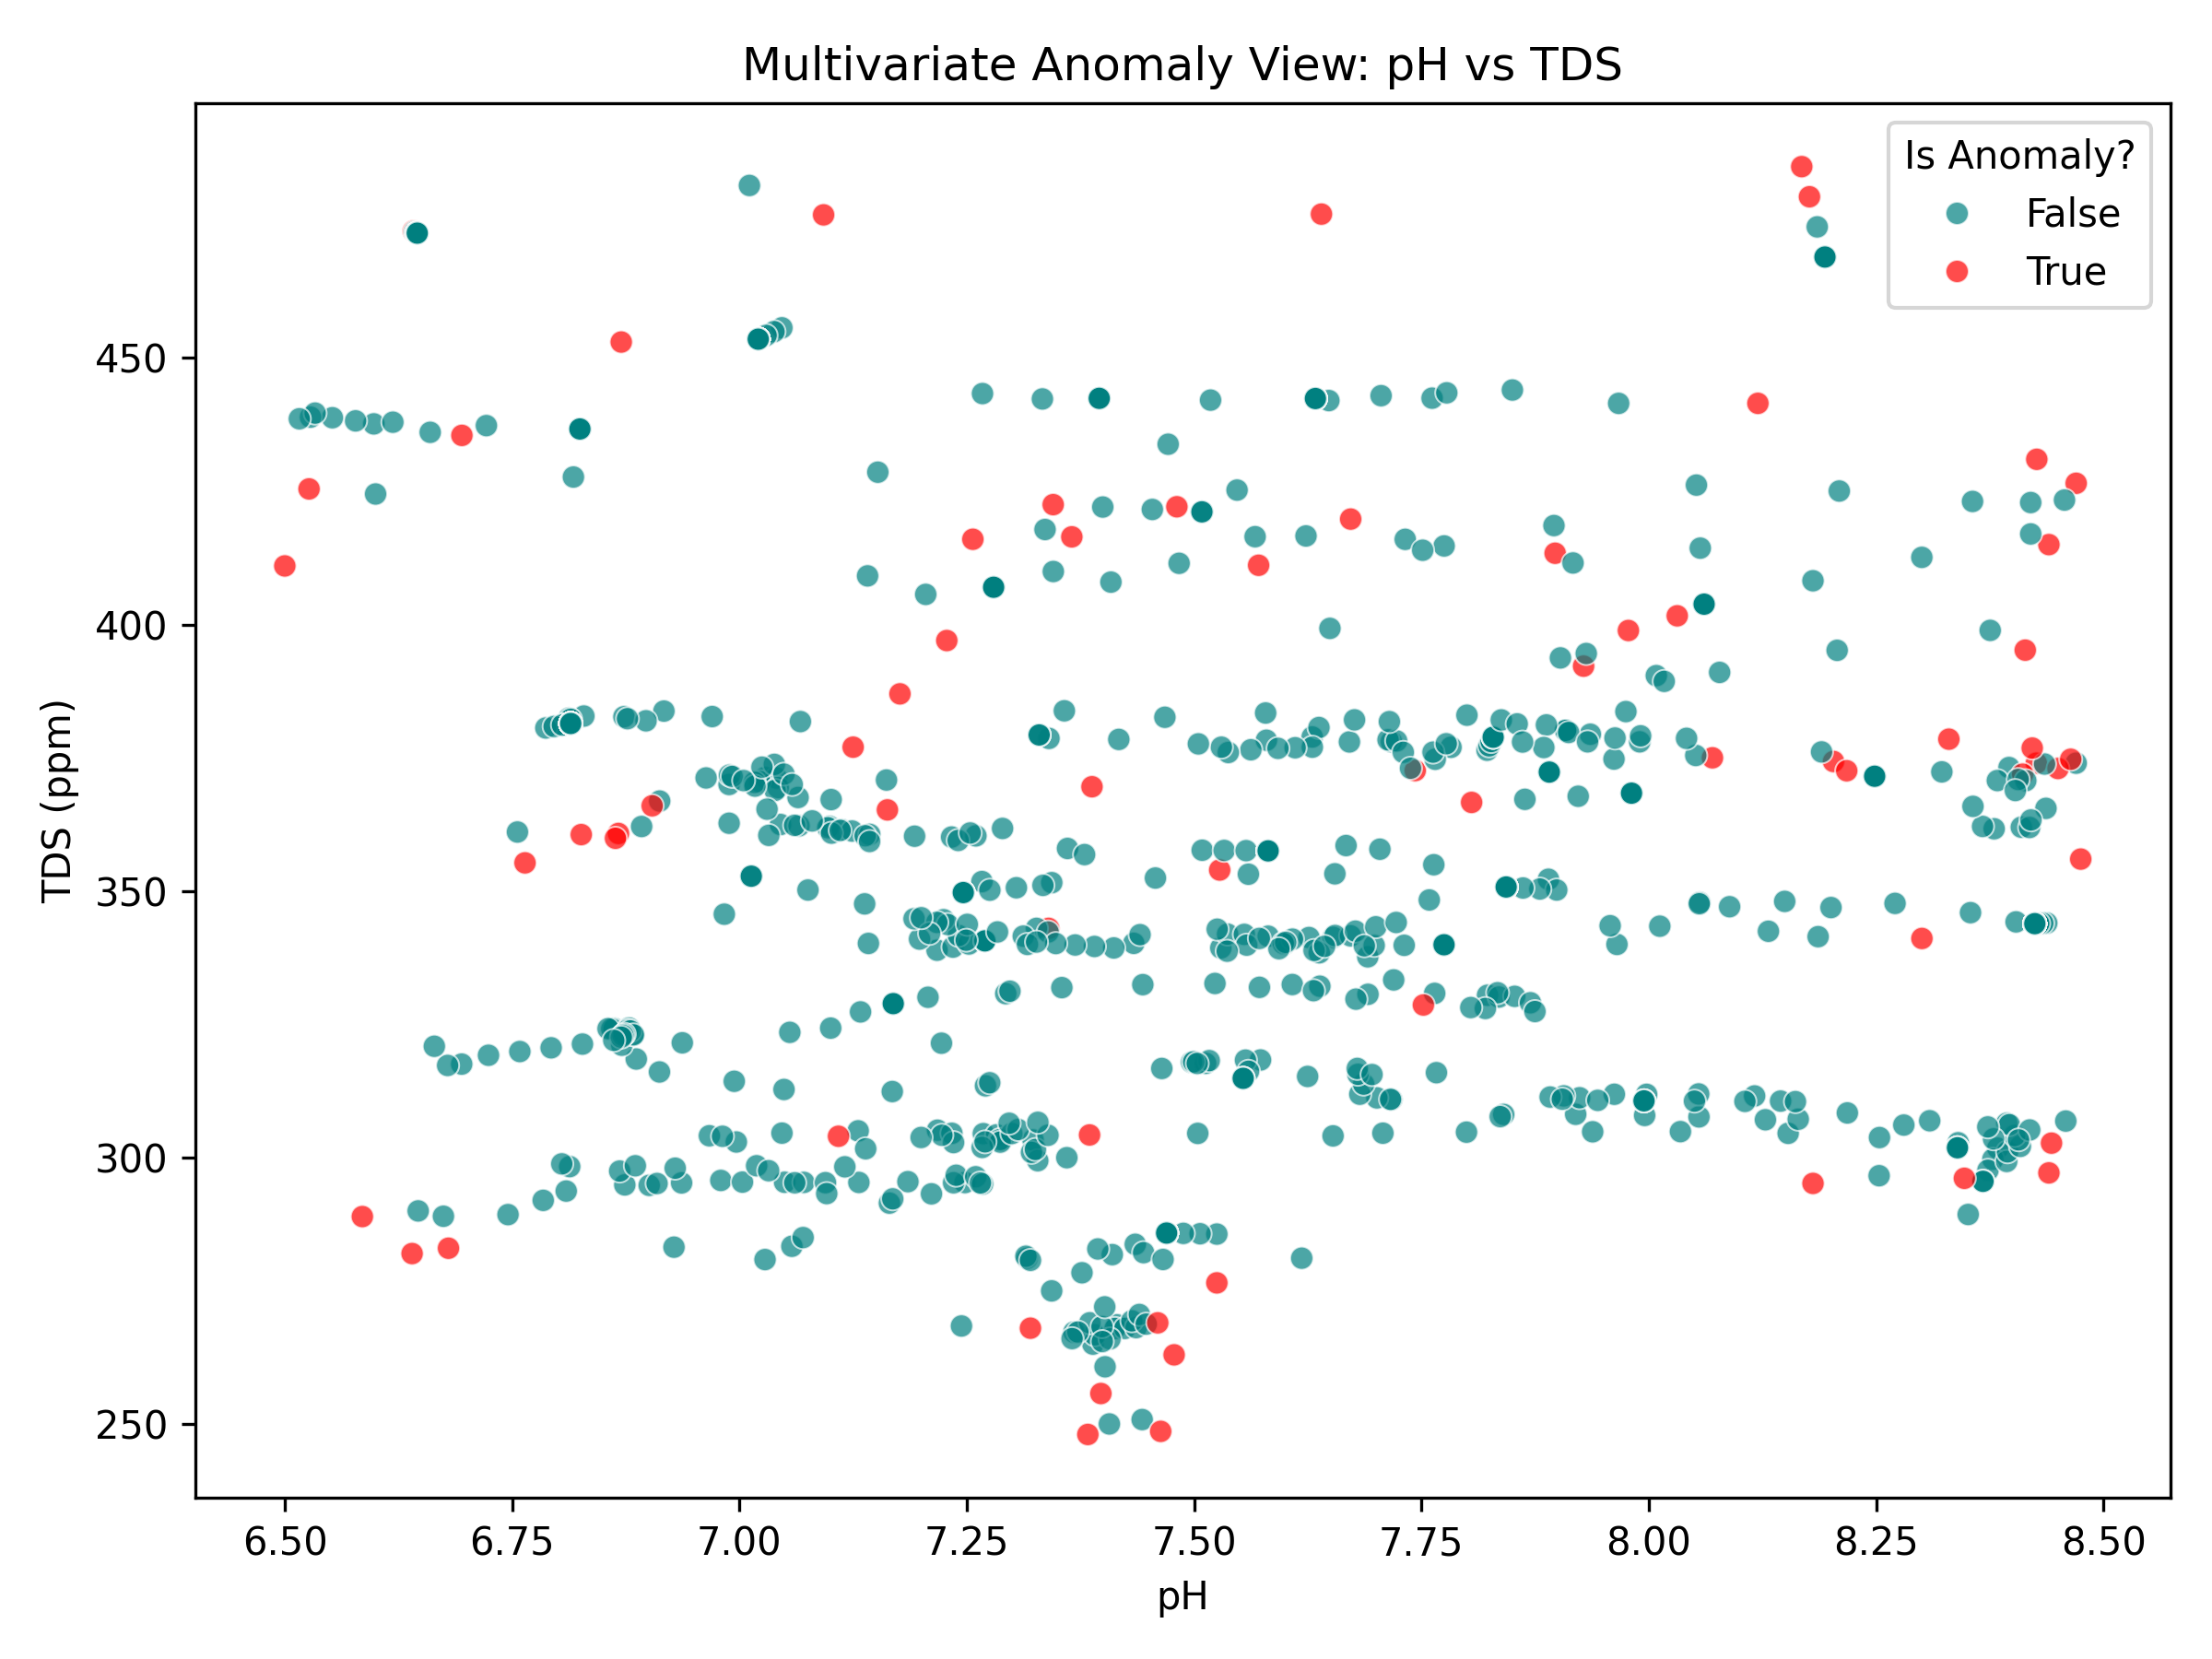
Figure 5.9: Model 3 bivariate scatter plot (pH vs. TDS) highlighting detected multivariate anomalies

Explanation: Normal pond observations form a dense cluster, while observations associated with multiple abnormal parameters are isolated by the algorithm.

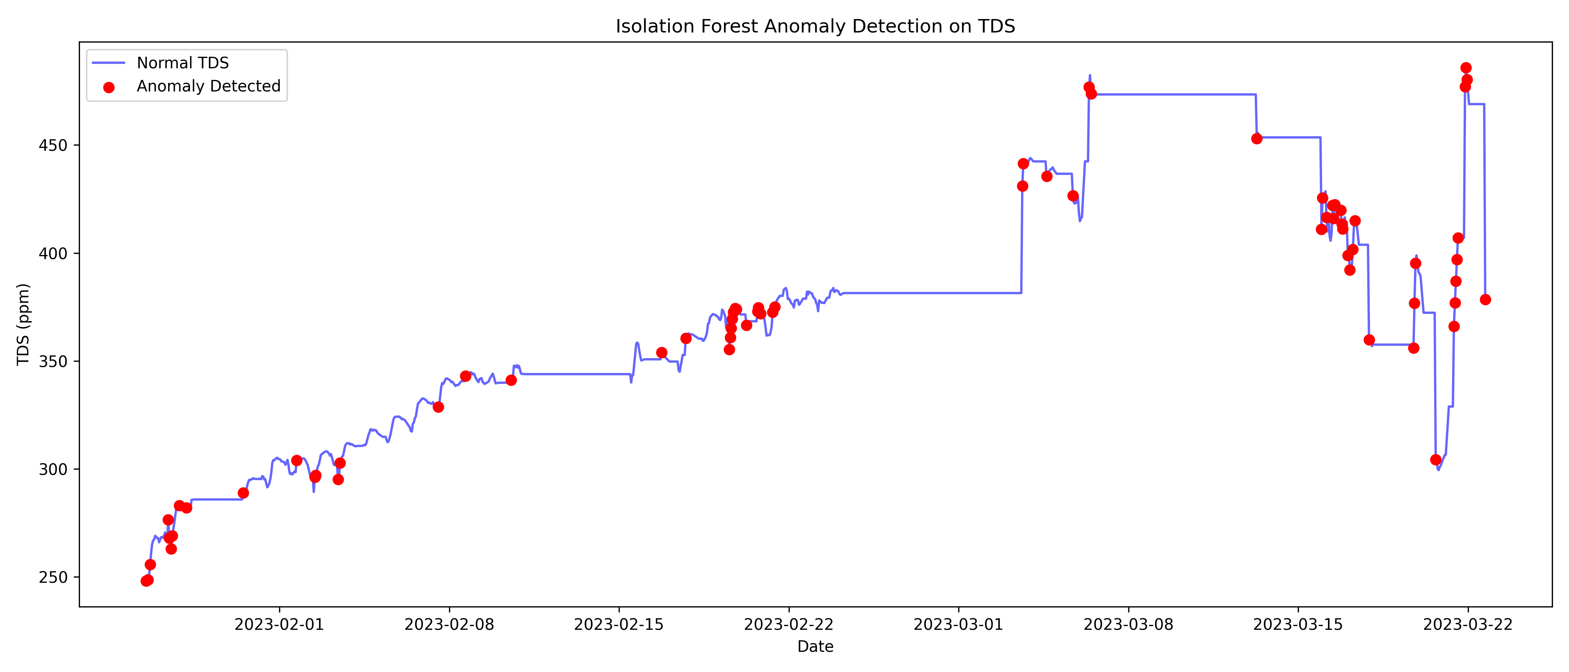
Figure 5.10: Model 3 anomaly detection timeline traced along continuous TDS sensor readings

Explanation: Red markers indicate sudden changes in the TDS time series associated with rapid environmental changes, such as fertilizer runoff or rain dilution.

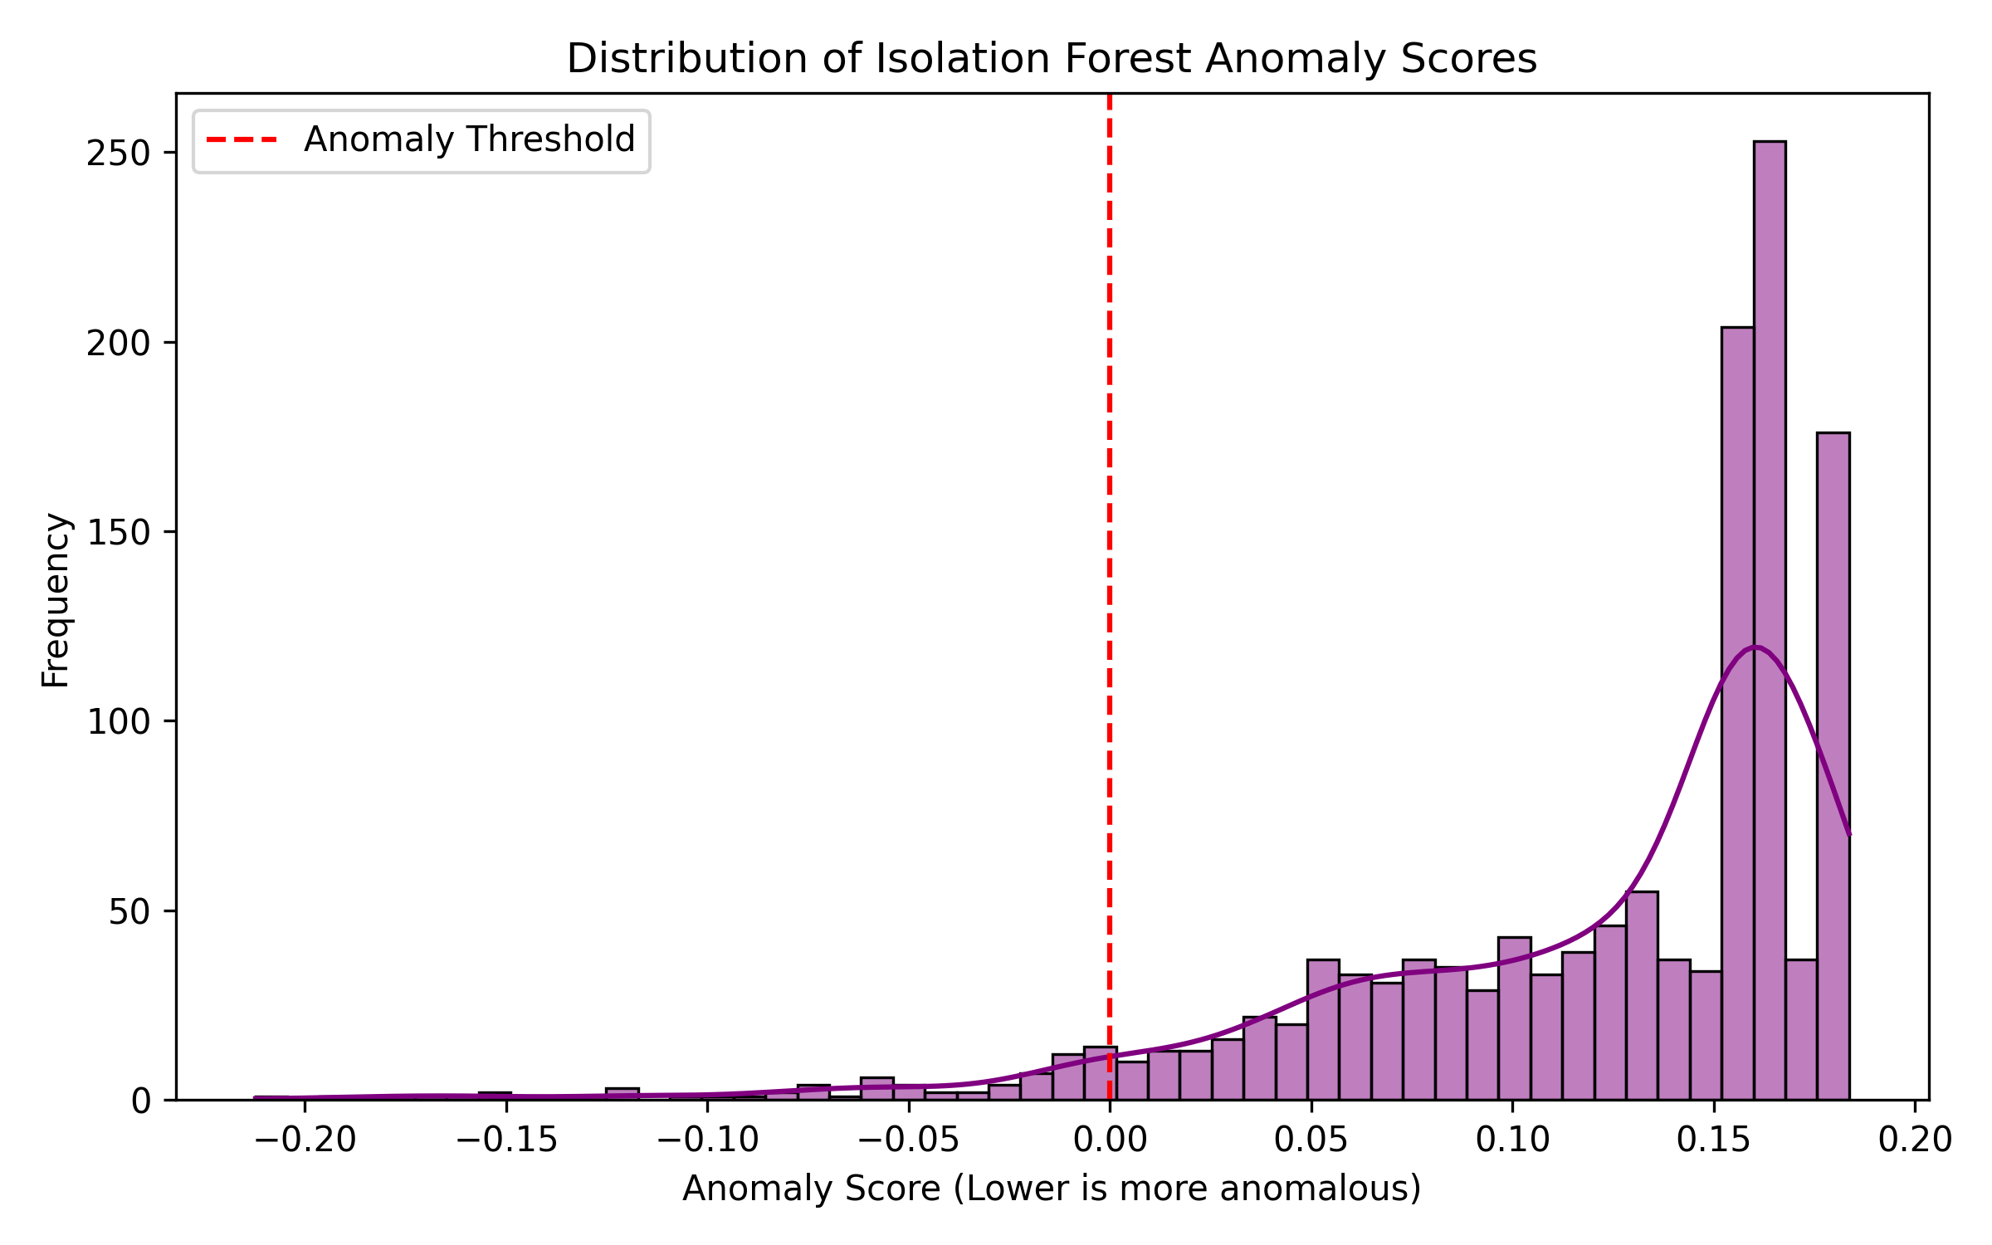
Figure 5.11: Isolation Forest anomaly score distribution and 5% contamination decision threshold

Explanation: The histogram presents the computed anomaly scores, with the decision threshold corresponding to the selected 5% contamination level.

5.6 Real-Time Actuation and Inference Latency
System responsiveness was evaluated across 1,000 test cycles, with representative edge sampling, local relay actuation, and machine-learning inference latency summarized in Table 5.8.
Table 5.8: End-to-End Latency Benchmark Results
Subsystem Operation / Benchmark | Measured Average Latency | Maximum Observed Latency | Operational Reliability Standard
Edge Sensor Sampling & ADC Multi-Sampling | 42 ms | 68 ms | Deterministic 30-second cycle
Local Fail-Safe Relay Actuation (Edge FSM) | 65 ms | 85 ms | Instantaneous emergency protection
Machine Learning Inference API Latency | 18 ms | 32 ms | Millisecond-scale REST model inference

5.7 Comprehensive Discussion & Technical Defense Insights
Four Key Findings. (1) Leave-One-Year-Out validation is important for river time-series data because random shuffling can introduce future-data leakage; (2) linear regression models provide stronger peak extrapolation than the evaluated tree-based models; (3) Isolation Forest can identify combined abnormal conditions without requiring pre-labeled failure datasets; and (4) SHAP provides an interpretable view of the features contributing to the TDS forecasting model.

5.8 Conclusion
The experiments demonstrated the performance of the evaluated subsystems: the calibrated sensors achieved the reported measurement accuracy; Model 1 achieved an NSE of 0.9851 on the reported holdout evaluation; Model 2 provided short-horizon TDS forecasts with SHAP-based interpretation, with the persistence baseline outperforming the learned models overall; Model 3 identified multivariate anomalies; and the edge control logic continues to operate locally during network interruptions.

Chapter 6: Conclusion and Future Work

6.1 Conclusion
AquaShield integrates low-cost IoT automation with three machine learning models to address pond water-quality monitoring and monsoon flood risks in Bangladesh. The prototype was developed within a target hardware cost of 7,200 BDT (~$60 USD). The project demonstrates the feasibility of combining local edge control, cloud telemetry, predictive modeling, and anomaly detection in a single aquaculture decision-support system. The principal engineering and research contributions are summarized below.
Project Limitations.
1. Sensor Bio-Fouling: Glass-bulb pH probes require periodic cleaning every 2 to 4 weeks to remove biofilm.
2. Wi-Fi Coverage: The prototype uses 2.4 GHz Wi-Fi, meaning remote ponds without Wi-Fi require a GSM-based communication module.
3. Single-Station Scope: Model 1 was calibrated specifically for the Bahadurabad transit station on the Jamuna River.

6.2 Future Work
1. LoRaWAN Long-Range Mesh: Use LoRaWAN transceivers to connect multiple ponds across a 10 km radius to a single gateway.
2. On-Device TinyML Inference: Convert suitable models with TinyML to run predictions directly on the ESP32 microcontroller.
3. Solar Off-Grid Power: Add a 50W solar panel and 12V battery for off-grid operation in rural areas.

Appendix A: Hardware Pin Mappings and REST API Endpoints

A.1 Complete Hardware Pinout Specifications
Table A.1: Complete Hardware Pinout and Bus Interfacing Specifications
ESP32 Pin | Component Name | Signal Category | Operating Voltage | Bus Protocol / Interface Circuit
GPIO 34 | pH Sensor (pH-4502C) | Analog Input | 0.0V -- 3.3V DC | ADC1 Channel 6 (Wi-Fi safe, multi-sampled)
GPIO 35 | TDS Sensor (Analog Out) | Analog Input | 0.0V -- 2.3V DC | ADC1 Channel 7 (Wi-Fi safe, multi-sampled)
ADC pin [GPIO 32] | NTC Thermistor (Temperature) | Analog Input | 3.3V DC | Voltage divider with 4.7 kΩ pull-down resistor
GPIO 5 | Ultrasonic Trig Pin | Digital Output | 3.3V / 5.0V TTL | 10 μs trigger pulse output
GPIO 18 | Ultrasonic Echo Pin | Digital Input | 3.3V Logic Level | Pulse-width return via 1kΩ/2kΩ voltage divider
GPIO 25 | Relay 1 (Drain Pump) | Digital Output | 3.3V GPIO control; 5.0V relay-module supply | Active-LOW optocoupler trigger driver
GPIO 26 | Relay 2 (Refill Pump) | Digital Output | 3.3V GPIO control; 5.0V relay-module supply | Active-LOW optocoupler trigger driver
GPIO 13 | Servo Motor (Feeder) | PWM Output | 3.3V PWM control; 5.0V external servo supply | 50 Hz hardware PWM (1.0 ms -- 2.0 ms duty cycle)
3.3V | pH Sensor (pH-4502C) & TDS Sensor Supply | Sensor Power Rail | 3.3V DC | Used instead of the standard 5V to protect the ESP32 ADC pins
VIN / 5V | LM2596 Output Rail | Regulated Power | 5.0V DC (±2%) | Filtered with 470 μF + 0.1 μF capacitors
GND | Common Ground | Ground Rail | 0.0V Reference | Common ground plane for MCU, sensors, and power

A.2 AquaShield REST API Endpoints Specification
Live sensor telemetry, historical records, pump command states, and calibration values are exchanged through the Firebase Realtime Database; the REST endpoints below are served by the Python FastAPI machine learning backend.
Table A.2: AquaShield REST API Endpoints Specification (Python FastAPI ML Backend)
HTTP Method | API Route Endpoint | Payload / Parameters | Description & Response Output
GET | /api/v1/forecast | horizon=3 | Returns predicted Bahadurabad river water level and alert tier
GET | /api/v1/tds | device_id | Returns predicted +60m TDS value with SHAP feature rankings
GET | /api/v1/anomaly | device_id | Returns current Isolation Forest score and multivariate flag

References
[1] Department of Fisheries (DoF), 'Yearbook of Fisheries Statistics of Bangladesh 2022-23,' Ministry of Fisheries and Livestock, Dhaka, 2023.
[2] Food and Agriculture Organization (FAO), 'The State of World Fisheries and Aquaculture 2024,' FAO, Rome, Italy, 2024.
[3] Flood Forecasting and Warning Centre (FFWC), 'Annual Flood Report 2020,' BWDB, Dhaka, Bangladesh, 2021.
[4] M. M. Rahman, M. A. Hossain, and S. Islam, 'Impact of climate change and extreme monsoon flooding on inland aquaculture in northern Bangladesh,' Journal of Water and Climate Change, vol. 12, no. 4, pp. 1420--1435, 2021.
[5] C. E. Boyd, Water Quality: An Introduction, 3rd ed., Cham, Switzerland: Springer Nature, 2020.
[6] J. E. Colt, Dissolved Gas Concentration in Water, 2nd ed., London: Academic Press, 2012.
[7] P. Saha, D. Biswas, and A. K. Das, 'IoT-based automated water quality monitoring and alert system for fish farming,' in Proc. IEEE ICSCEE, Shah Alam, Malaysia, 2018, pp. 1--6.
[8] K. R. Raju, G. H. Kumar, and M. V. Reddy, 'Automated water quality monitoring and control system for aquaculture using Raspberry Pi,' IEEE IoT Journal, vol. 7, no. 9, pp. 8412--8421, 2020.
[9] M. R. Hasan, M. S. Alam, and T. Sultana, 'Design and deployment of a low-cost IoT telemetry node for rural fish ponds in Bangladesh,' in Proc. IEEE ICEEICT, Dhaka, 2021, pp. 215--220.
[10] M. N. Islam, S. K. Roy, and R. Ahmed, 'Predictive water aeration and quality management using ESP32 edge microcontroller,' IEEE Access, vol. 10, pp. 54312--54324, 2022.
[11] X. Chen, Y. Zhang, and L. Wang, 'Industrial PLC-driven multi-parameter recirculating aquaculture control system with deep LSTM DO prediction,' Computers and Electronics in Agriculture, vol. 205, art. no. 107621, 2023.
[12] S. Ahmed, F. Farzana, and K. M. Kabir, 'Automated fish feeding and pond level management system using IoT relays and ultrasonic sensing,' in Proc. IEEE CONECCT, Bangalore, 2024, pp. 1--6.
[13] F. T. Liu, K. M. Ting, and Z.-H. Zhou, 'Isolation Forest,' in Proc. 8th IEEE ICDM, Pisa, Italy, 2008, pp. 413--422.
[14] S. M. Lundberg and S.-I. Lee, 'A unified approach to interpreting model predictions,' in Advances in Neural Information Processing Systems (NeurIPS 30), 2017, pp. 4765--4774.
[15] T. Chen and C. Guestrin, 'XGBoost: A scalable tree boosting system,' in Proc. 22nd ACM SIGKDD, 2016, pp. 785--794.
[16] L. Breiman, 'Random Forests,' Machine Learning, vol. 45, no. 1, pp. 5--32, 2001.
[17] A. E. Hoerl and R. W. Kennard, 'Ridge regression: Biased estimation for nonorthogonal problems,' Technometrics, vol. 12, no. 1, pp. 55--67, 1970.
[18] R. Tibshirani, 'Regression shrinkage and selection via the Lasso,' Journal of the Royal Statistical Society: Series B, vol. 58, no. 1, pp. 267--288, 1996.
[19] J. E. Nash and J. V. Sutcliffe, 'River flow forecasting through conceptual models part I,' Journal of Hydrology, vol. 10, no. 3, pp. 282--290, 1970.
[20] H. Hersbach et al., 'The ERA5 global reanalysis,' Quarterly Journal of the Royal Meteorological Society, vol. 146, no. 730, pp. 1999--2049, 2020.
[21] Bangladesh Water Development Board (BWDB), 'Hydrometric Data Portal: Daily Water Levels and Discharges (Station SW46.9L),' BWDB Hydrology Division, Dhaka, 2024.
[22] Espressif Systems, 'ESP32 Series Datasheet: 2.4 GHz Wi-Fi and Bluetooth Combo Chip,' Espressif Systems, Shanghai, China, 2023.
[23] F. Pedregosa et al., 'Scikit-learn: Machine learning in Python,' Journal of Machine Learning Research, vol. 12, pp. 2825--2830, 2011.
[24] Board of Accreditation for Engineering and Technical Education (BAETE), 'Manual for Accrediting Undergraduate Engineering Programmes,' IEB, Dhaka, Ver. 2.1, 2023.
[25] University of Information Technology and Sciences (UITS), 'Capstone Project and Thesis Guidelines: Department of Computer Science and Engineering,' UITS Academic Council, Dhaka, Bangladesh, 2026.

Plagiarism Report
[Official Institutional Plagiarism Verification Report to be inserted here]
In accordance with Department of Computer Science and Engineering capstone guidelines, the final project book must include the official similarity report from the university-designated plagiarism checking software (Turnitin / iThenticate). Upon completion of the final defense and review board revisions, the verified digital originality certificate will be attached to this designated section prior to final hardcover binding.

Supervisor: Sultana Rokeya Naher, Associate Professor

